**AWS Cloud & Big Data Architectures - Project**

# Design an architecture diagram

Commencez par créer le diagramme d'architecture pour visualiser l'ensemble de votre solution. Cela vous aidera à planifier la disposition des composants et à prendre des décisions éclairées concernant la configuration.

# Deploy app

## Create the VPC

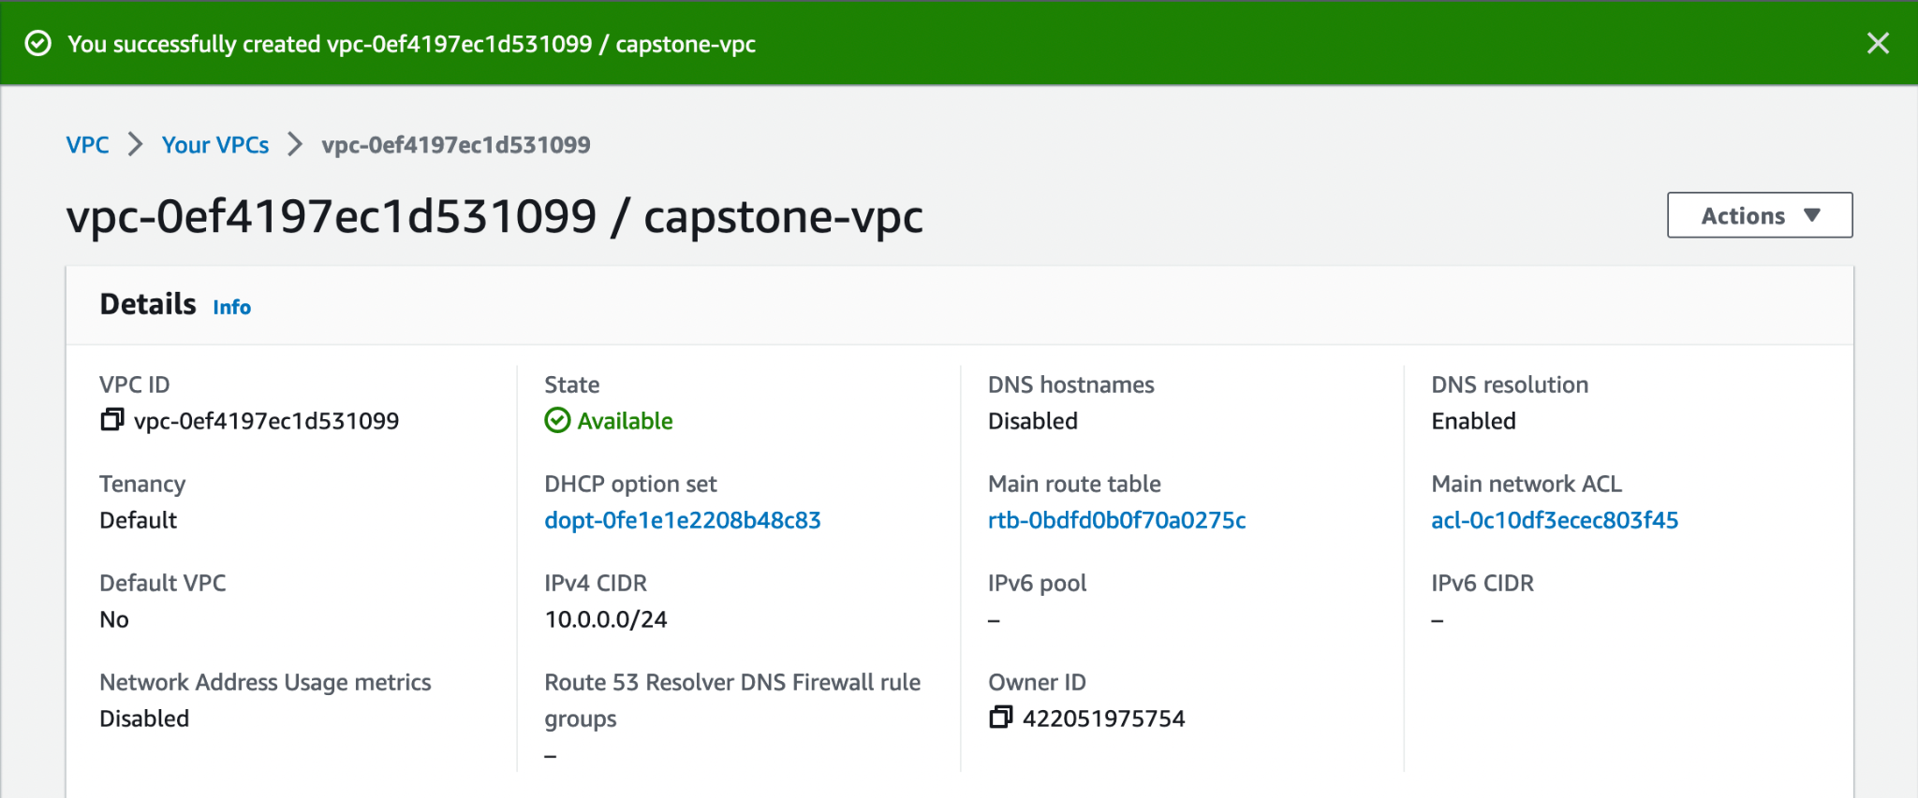

## create internet gateway

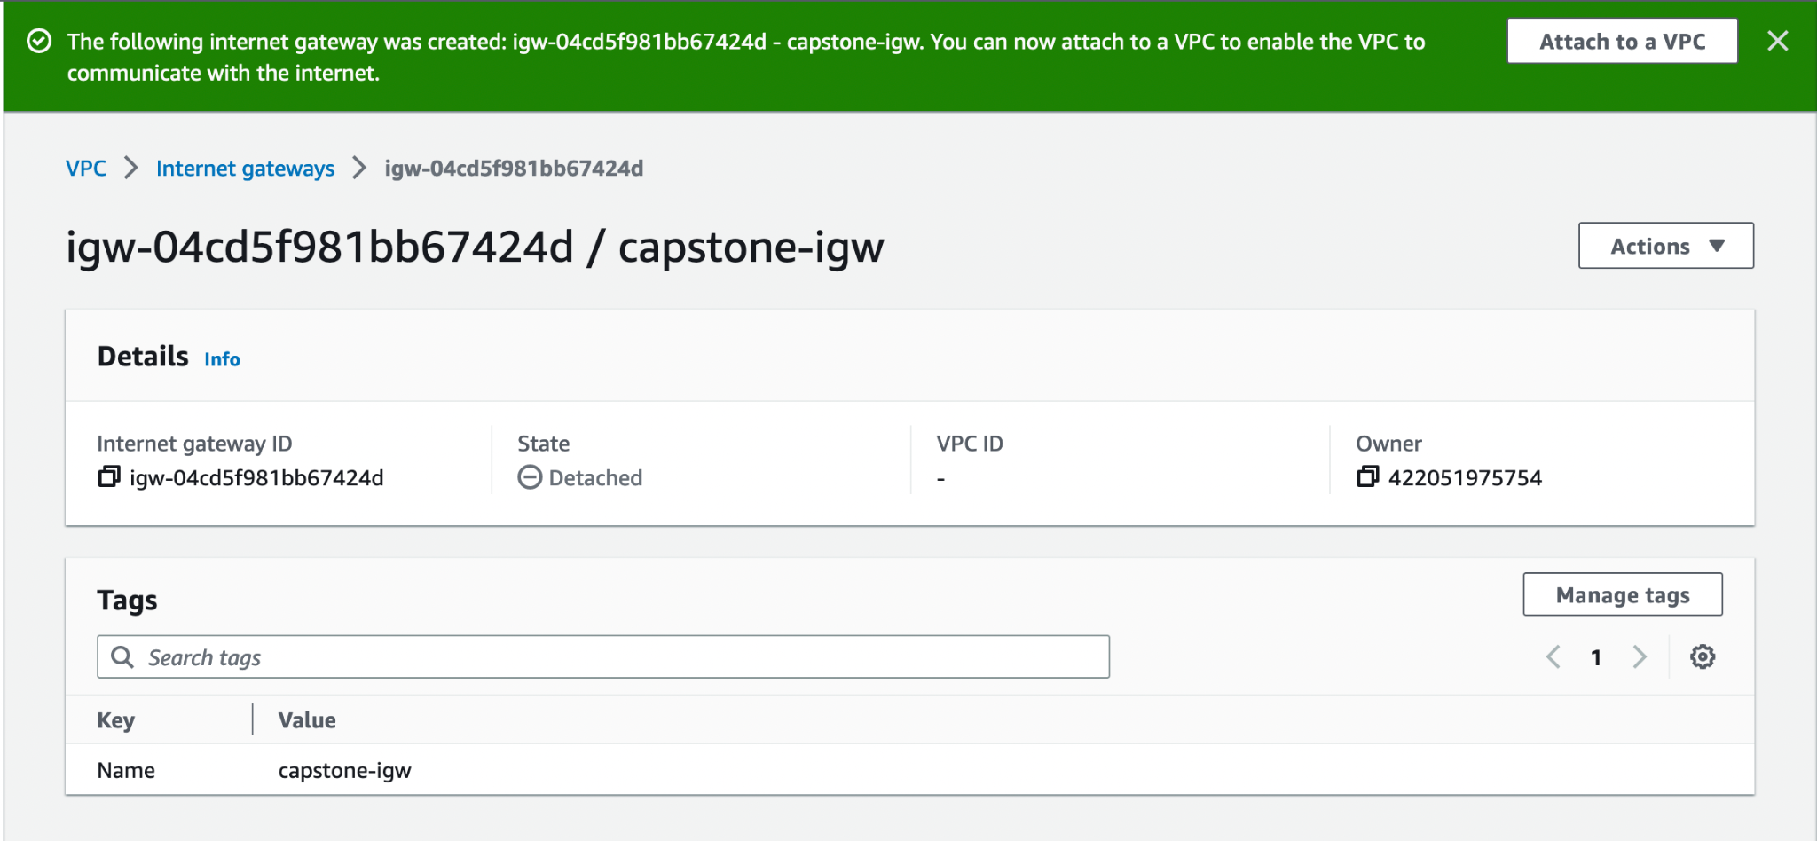

## Attach it to the VPC

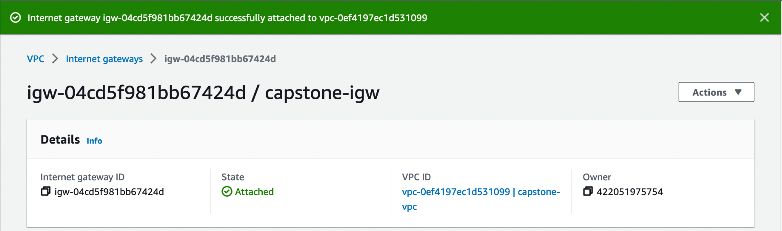

## And edit the route table to add new route to the internet getaway

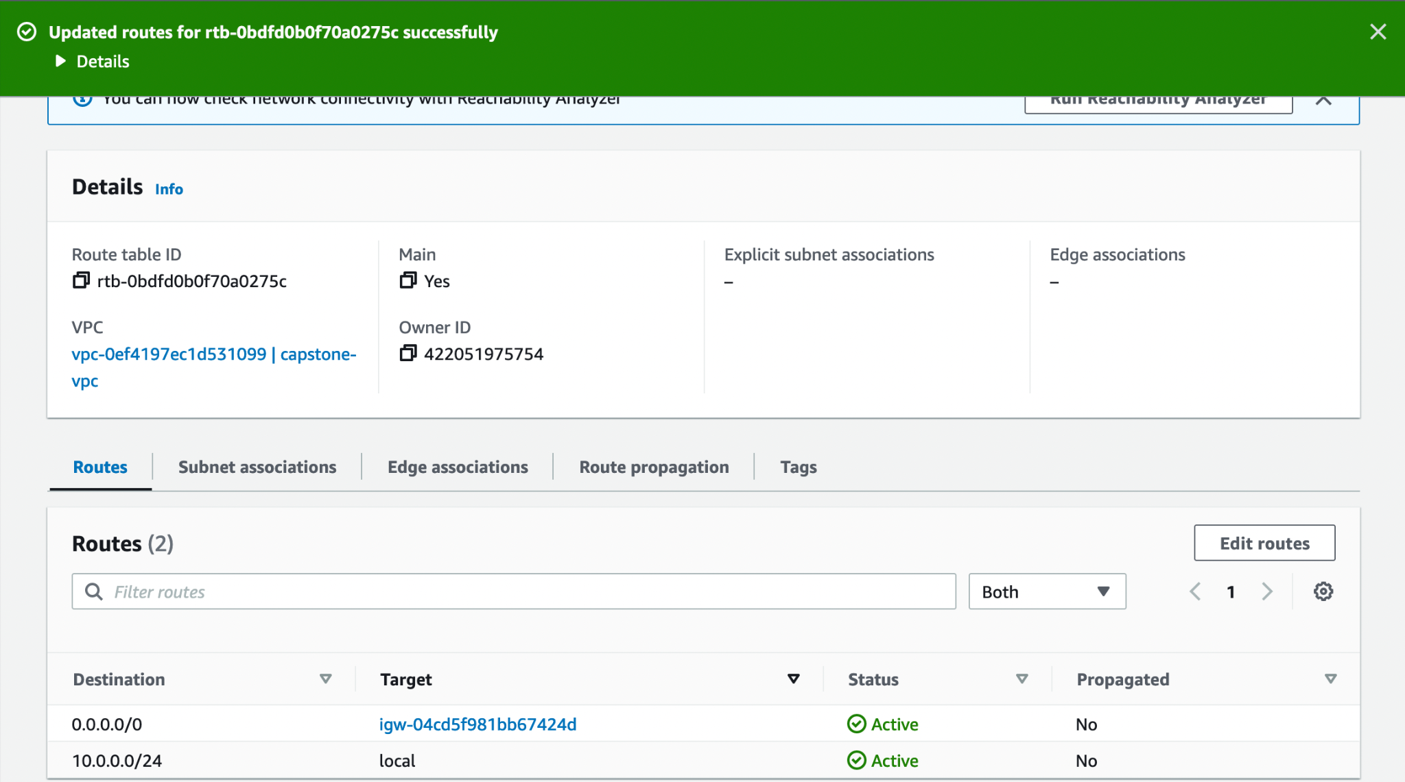

## Create 2 subsets, 1 public for EC2 instance and 1 private for RDS Database

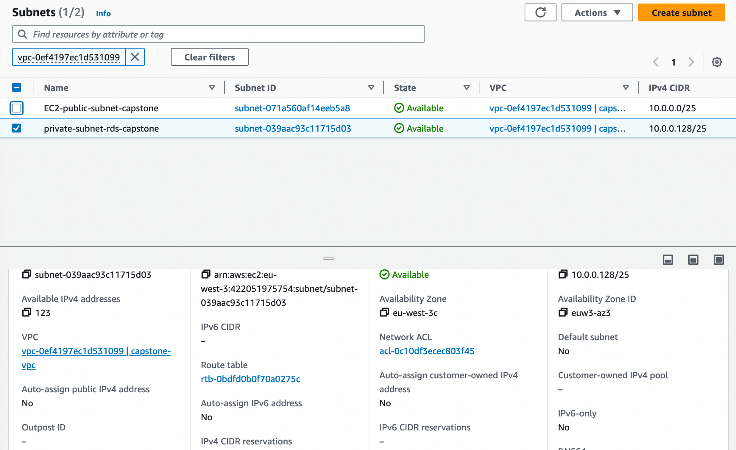

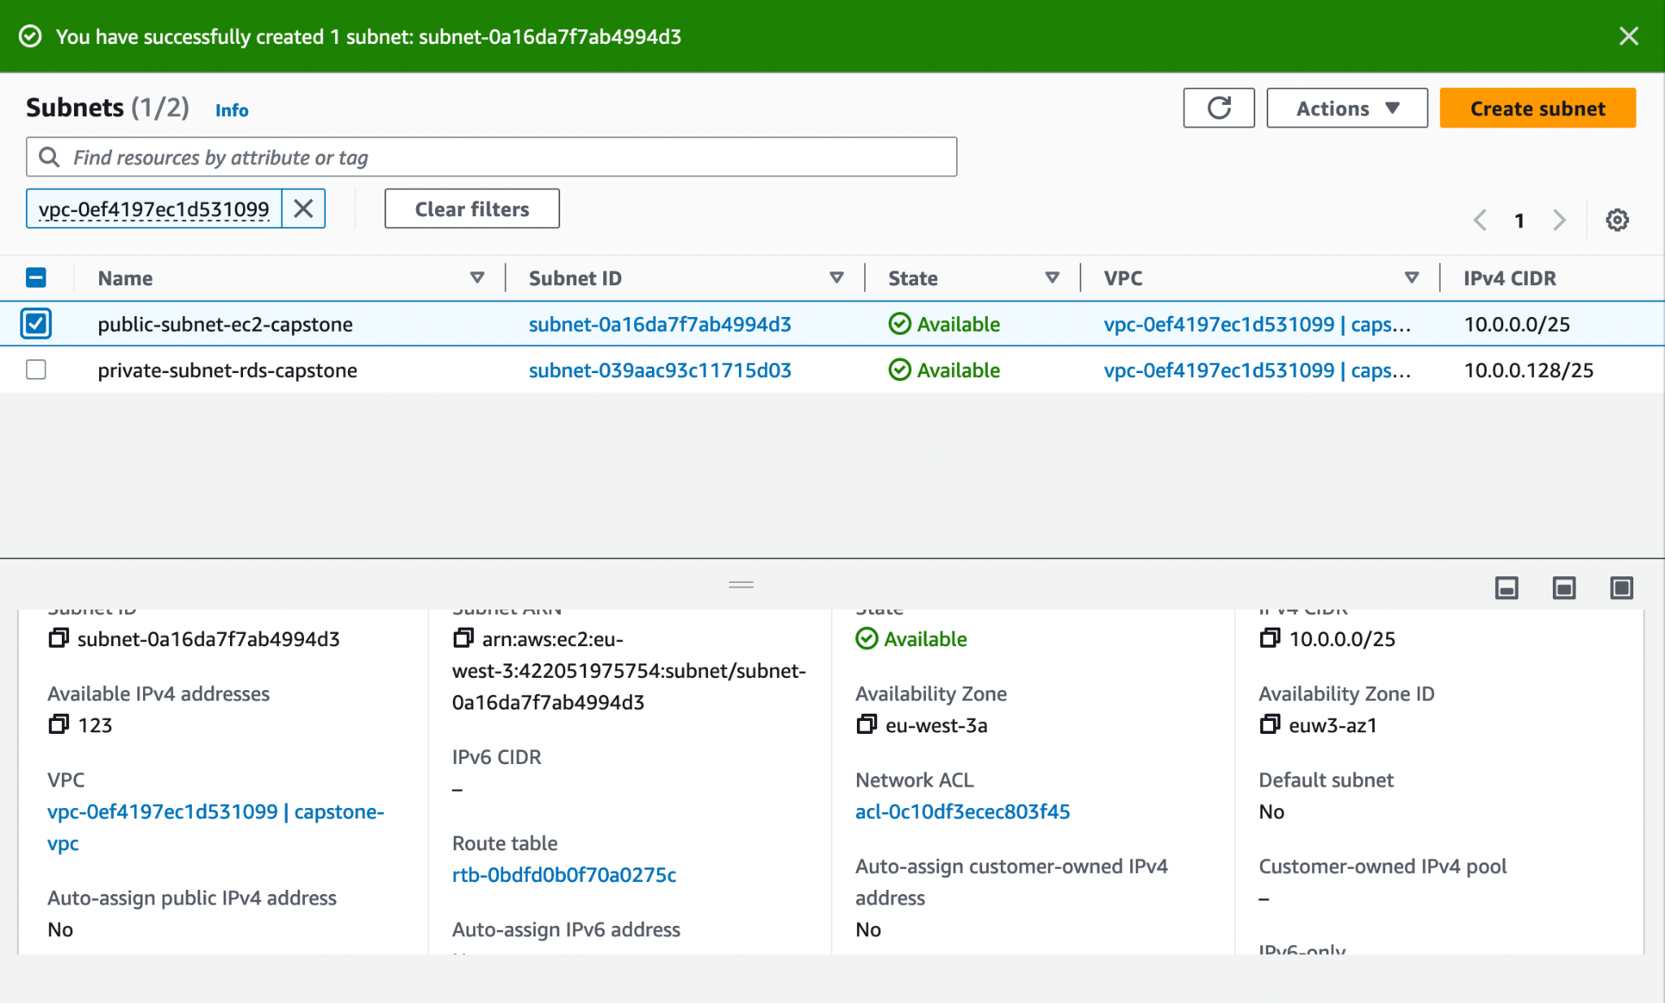

## Configurer l'instance RDS (Create a private database) :

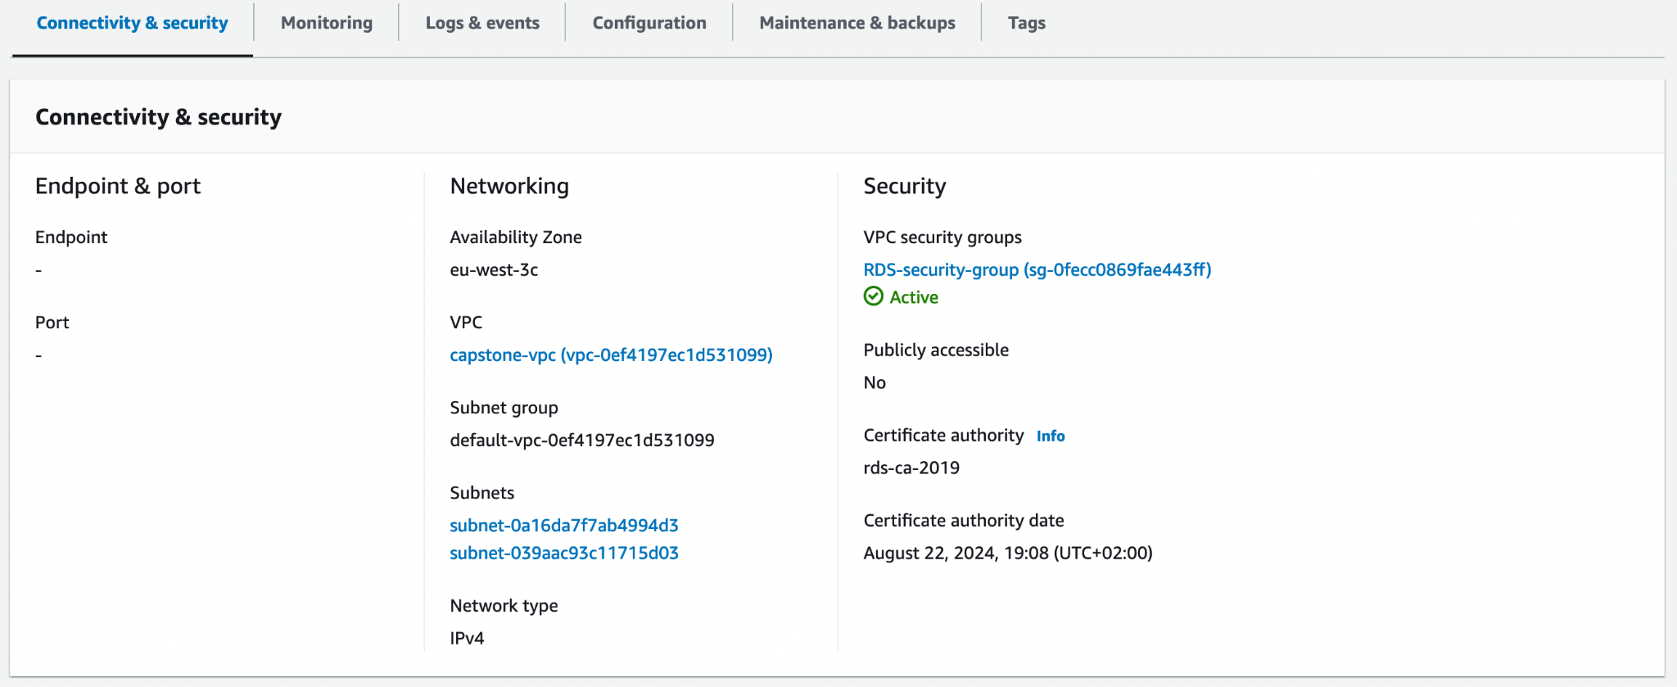

## **Configurer le groupe de sécurité RDS :**

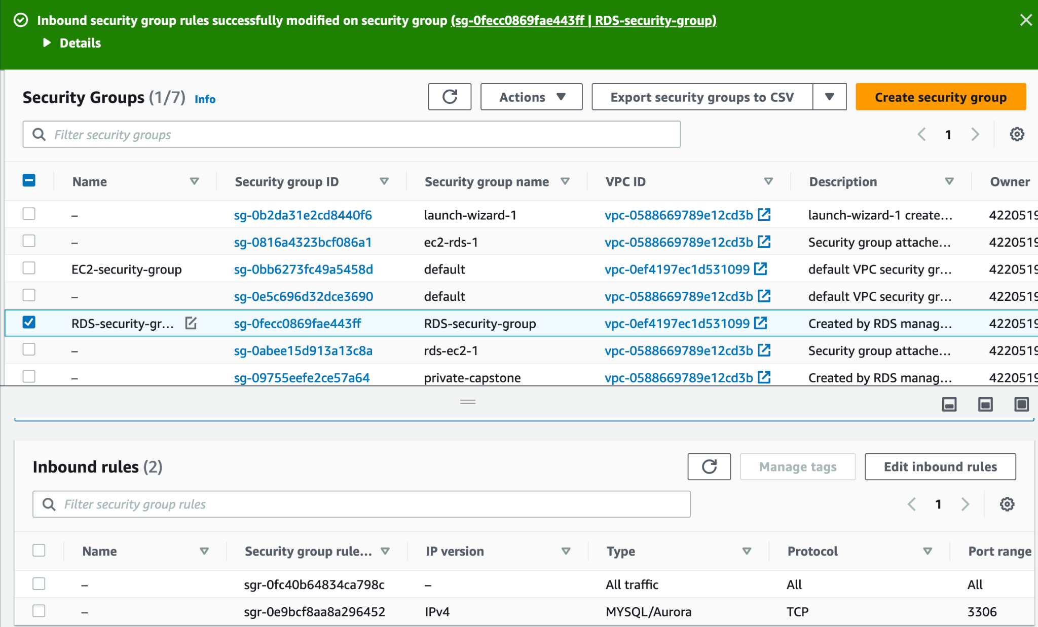

## Configurer les paramètres du SSM Parameter Store :

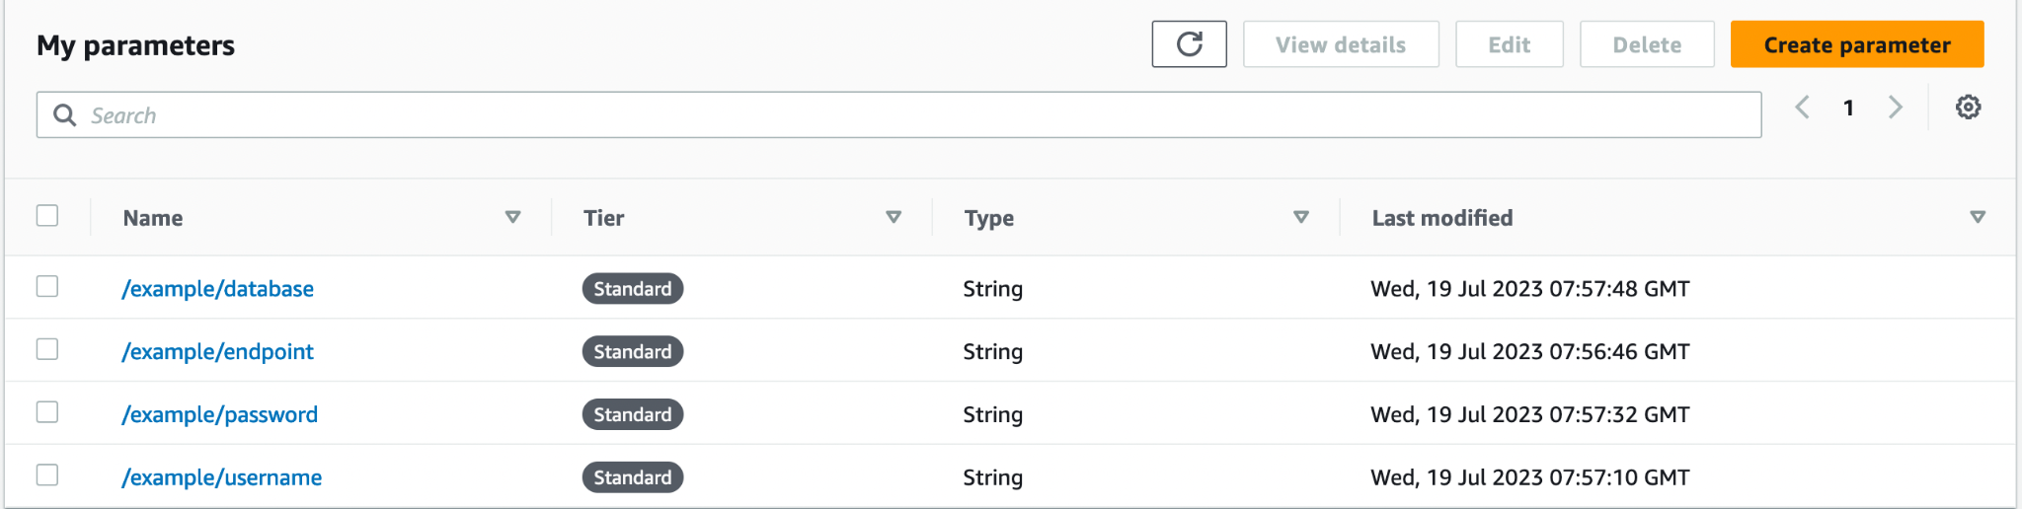

## Create EC2 public instance

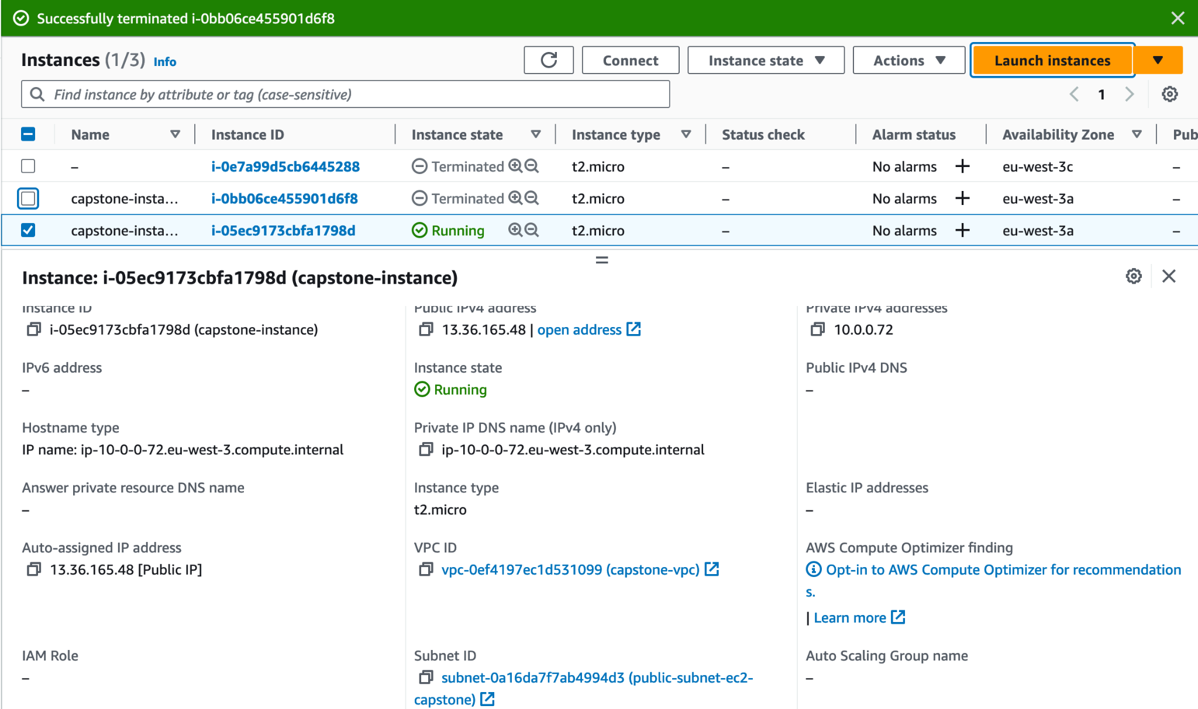

## Configure rules for EC2 security group :

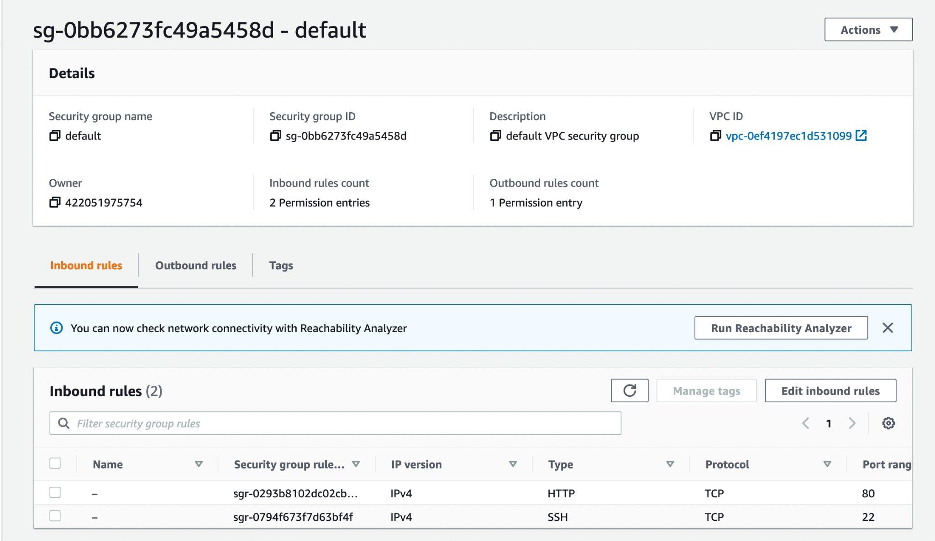

## **Deploy PHP application :**

| simonmartinenq@MacBook-Pro-de-simon Downloads % ssh -i capstone-pair.pem ec2-user@13.36.165.48 Last login: Wed Jul 19 09:09:59 2023 from 217.26.204.244   __| __|_ )  _| ( / Amazon Linux 2 AMI  ___|\___|___|  https://aws.amazon.com/amazon-linux-2/ No packages needed for security; 2 packages available Run "sudo yum update" to apply all updates. :~ $ sudo -i [root@ip-10-0-0-72 ~]# yum -y update Modules complémentaires chargés : extras_suggestions, langpacks, priorities, update-motd 244 packages excluded due to repository priority protections Résolution des dépendances --> Lancement de la transaction de test ---> Le paquet iputils.x86_64 0:20160308-10.amzn2.0.2 sera mis à jour ---> Le paquet iputils.x86_64 0:20180629-11.amzn2.1.20160308 sera utilisé ---> Le paquet terraform.x86_64 0:1.5.1-1 sera mis à jour ---> Le paquet terraform.x86_64 0:1.5.3-1 sera utilisé --> Résolution des dépendances terminée  Dépendances résolues  ======================================================================================================================  Package Architecture Version Dépôt Taille ====================================================================================================================== Mise à jour :  iputils x86_64 20180629-11.amzn2.1.20160308 amzn2-core 147 k  terraform x86_64 1.5.3-1 hashicorp 21 M  Résumé de la transaction ====================================================================================================================== Mettre à jour 2 Paquets  Taille totale des téléchargements : 21 M Downloading packages: Delta RPMs disabled because /usr/bin/applydeltarpm not installed. (1/2): iputils-20180629-11.amzn2.1.20160308.x86_64.rpm | 147 kB 00:00:00  (2/2): terraform-1.5.3-1.x86_64.rpm | 21 MB 00:00:00  ---------------------------------------------------------------------------------------------------------------------- Total 37 MB/s | 21 MB 00:00:00  Running transaction check Running transaction test Transaction test succeeded Running transaction  Mise à jour : iputils-20180629-11.amzn2.1.20160308.x86_64 2/4  Nettoyage : terraform-1.5.1-1.x86_64 3/4  Nettoyage : iputils-20160308-10.amzn2.0.2.x86_64 4/4  Vérification : iputils-20180629-11.amzn2.1.20160308.x86_64 1/4  Vérification : terraform-1.5.3-1.x86_64 2/4  Vérification : terraform-1.5.1-1.x86_64 3/4  Vérification : iputils-20160308-10.amzn2.0.2.x86_64 4/4  Mis à jour :  iputils.x86_64 0:20180629-11.amzn2.1.20160308 terraform.x86_64 0:1.5.3-1   Terminé ! [root@ip-10-0-0-72 ~]# amazon-linux-extras install -y lamp-mariadb10.2-php7.2 php7.2  Topic php7.2 has end-of-support date of 2020-11-30 Installing php-pdo, php-mysqlnd, php-fpm, php-cli, php-json, mariadb Modules complémentaires chargés : extras_suggestions, langpacks, priorities, update-motd Verrou /var/run/yum.pid existant : une autre copie est lancée avec le pid 27355. Another app is currently holding the yum lock; waiting for it to exit... Il s'agit de yum  Mémoire : 228 M RSS (445 MB VSZ)  Débuté : Wed Jul 19 09:11:06 2023 - il y a 00:04  État : Exécution, pid : 27355 Another app is currently holding the yum lock; waiting for it to exit... Il s'agit de yum  Mémoire : 308 M RSS (524 MB VSZ)  Débuté : Wed Jul 19 09:11:06 2023 - il y a 00:06  État : Exécution, pid : 27355 Another app is currently holding the yum lock; waiting for it to exit... Il s'agit de yum  Mémoire : 341 M RSS (557 MB VSZ)  Débuté : Wed Jul 19 09:11:06 2023 - il y a 00:08  État : Exécution, pid : 27355 Another app is currently holding the yum lock; waiting for it to exit... Il s'agit de yum  Mémoire : 343 M RSS (560 MB VSZ)  Débuté : Wed Jul 19 09:11:06 2023 - il y a 00:10  État : Exécution, pid : 27355 Nettoyage des dépôts : amzn2-core amzn2extra-docker amzn2extra-epel amzn2extra-lamp-mariadb10.2-php7.2  : amzn2extra-php7.2 epel hashicorp 35 metadata fichiers supprimés 16 sqlite fichiers supprimés 0 metadata fichier supprimé Modules complémentaires chargés : extras_suggestions, langpacks, priorities, update-motd amzn2-core | 3.7 kB 00:00:00  amzn2extra-docker | 3.0 kB 00:00:00  amzn2extra-epel | 3.0 kB 00:00:00  amzn2extra-lamp-mariadb10.2-php7.2 | 3.0 kB 00:00:00  amzn2extra-php7.2 | 3.0 kB 00:00:00  epel/x86_64/metalink | 24 kB 00:00:00  epel | 4.7 kB 00:00:00  hashicorp | 1.4 kB 00:00:00  (1/15): amzn2-core/2/x86_64/group_gz | 2.5 kB 00:00:00  (2/15): amzn2-core/2/x86_64/updateinfo | 637 kB 00:00:00  (3/15): amzn2extra-epel/2/x86_64/primary_db | 1.8 kB 00:00:00  (4/15): amzn2extra-lamp-mariadb10.2-php7.2/2/x86_64/updateinfo | 76 B 00:00:00  (5/15): amzn2extra-lamp-mariadb10.2-php7.2/2/x86_64/primary_db | 506 kB 00:00:00  (6/15): amzn2extra-php7.2/2/x86_64/updateinfo | 76 B 00:00:00  (7/15): amzn2extra-docker/2/x86_64/updateinfo | 9.8 kB 00:00:00  (8/15): amzn2extra-docker/2/x86_64/primary_db | 106 kB 00:00:00  (9/15): amzn2extra-epel/2/x86_64/updateinfo | 76 B 00:00:00  (10/15): amzn2extra-php7.2/2/x86_64/primary_db | 580 kB 00:00:00  (11/15): epel/x86_64/group_gz | 99 kB 00:00:00  (12/15): epel/x86_64/updateinfo | 1.0 MB 00:00:00  (13/15): amzn2-core/2/x86_64/primary_db | 74 MB 00:00:01  (14/15): hashicorp/x86_64/primary | 172 kB 00:00:00  (15/15): epel/x86_64/primary_db | 7.0 MB 00:00:00  hashicorp 1238/1238 245 packages excluded due to repository priority protections Le paquet 3:mariadb-10.2.38-1.amzn2.0.1.x86_64 est déjà installé dans sa dernière version Résolution des dépendances --> Lancement de la transaction de test ---> Le paquet php-cli.x86_64 0:7.2.24-1.amzn2.0.1 sera mis à jour --> Traitement de la dépendance : php-cli(x86-64) = 7.2.24-1.amzn2.0.1 pour le paquet : php-devel-7.2.24-1.amzn2.0.1.x86_64 ---> Le paquet php-cli.x86_64 0:7.2.34-1.amzn2 sera utilisé --> Traitement de la dépendance : php-common(x86-64) = 7.2.34-1.amzn2 pour le paquet : php-cli-7.2.34-1.amzn2.x86_64 ---> Le paquet php-fpm.x86_64 0:7.2.24-1.amzn2.0.1 sera mis à jour ---> Le paquet php-fpm.x86_64 0:7.2.34-1.amzn2 sera utilisé ---> Le paquet php-json.x86_64 0:7.2.24-1.amzn2.0.1 sera mis à jour ---> Le paquet php-json.x86_64 0:7.2.34-1.amzn2 sera utilisé ---> Le paquet php-mysqlnd.x86_64 0:7.2.24-1.amzn2.0.1 sera mis à jour ---> Le paquet php-mysqlnd.x86_64 0:7.2.34-1.amzn2 sera utilisé ---> Le paquet php-pdo.x86_64 0:7.2.24-1.amzn2.0.1 sera mis à jour ---> Le paquet php-pdo.x86_64 0:7.2.34-1.amzn2 sera utilisé --> Lancement de la transaction de test ---> Le paquet php-common.x86_64 0:7.2.24-1.amzn2.0.1 sera mis à jour --> Traitement de la dépendance : php-common(x86-64) = 7.2.24-1.amzn2.0.1 pour le paquet : php-xml-7.2.24-1.amzn2.0.1.x86_64 --> Traitement de la dépendance : php-common(x86-64) = 7.2.24-1.amzn2.0.1 pour le paquet : php-process-7.2.24-1.amzn2.0.1.x86_64 ---> Le paquet php-common.x86_64 0:7.2.34-1.amzn2 sera utilisé --> Traitement de la dépendance : libzip.so.5()(64bit) pour le paquet : php-common-7.2.34-1.amzn2.x86_64 ---> Le paquet php-devel.x86_64 0:7.2.24-1.amzn2.0.1 sera mis à jour ---> Le paquet php-devel.x86_64 0:7.2.34-1.amzn2 sera utilisé --> Lancement de la transaction de test ---> Le paquet libzip.x86_64 0:1.3.2-1.amzn2.0.1 sera installé ---> Le paquet php-process.x86_64 0:7.2.24-1.amzn2.0.1 sera mis à jour ---> Le paquet php-process.x86_64 0:7.2.34-1.amzn2 sera utilisé ---> Le paquet php-xml.x86_64 0:7.2.24-1.amzn2.0.1 sera mis à jour ---> Le paquet php-xml.x86_64 0:7.2.34-1.amzn2 sera utilisé --> Résolution des dépendances terminée  Dépendances résolues  ======================================================================================================================  Package Architecture Version Dépôt Taille ====================================================================================================================== Mise à jour :  php-cli x86_64 7.2.34-1.amzn2 amzn2extra-php7.2 4.4 M  php-fpm x86_64 7.2.34-1.amzn2 amzn2extra-php7.2 1.5 M  php-json x86_64 7.2.34-1.amzn2 amzn2extra-php7.2 71 k  php-mysqlnd x86_64 7.2.34-1.amzn2 amzn2extra-php7.2 238 k  php-pdo x86_64 7.2.34-1.amzn2 amzn2extra-php7.2 132 k Installation pour dépendances :  libzip x86_64 1.3.2-1.amzn2.0.1 amzn2-core 62 k Mise à jour pour dépendances :  php-common x86_64 7.2.34-1.amzn2 amzn2extra-php7.2 1.1 M  php-devel x86_64 7.2.34-1.amzn2 amzn2extra-php7.2 1.2 M  php-process x86_64 7.2.34-1.amzn2 amzn2extra-php7.2 88 k  php-xml x86_64 7.2.34-1.amzn2 amzn2extra-php7.2 212 k  Résumé de la transaction ====================================================================================================================== Installation ( 1 Paquet en dépendance) Mettre à jour 5 Paquets (+4 Paquets en dépendance)  Taille totale des téléchargements : 8.9 M Downloading packages: Delta RPMs disabled because /usr/bin/applydeltarpm not installed. (1/10): libzip-1.3.2-1.amzn2.0.1.x86_64.rpm | 62 kB 00:00:00  (2/10): php-common-7.2.34-1.amzn2.x86_64.rpm | 1.1 MB 00:00:00  (3/10): php-devel-7.2.34-1.amzn2.x86_64.rpm | 1.2 MB 00:00:00  (4/10): php-fpm-7.2.34-1.amzn2.x86_64.rpm | 1.5 MB 00:00:00  (5/10): php-cli-7.2.34-1.amzn2.x86_64.rpm | 4.4 MB 00:00:00  (6/10): php-json-7.2.34-1.amzn2.x86_64.rpm | 71 kB 00:00:00  (7/10): php-mysqlnd-7.2.34-1.amzn2.x86_64.rpm | 238 kB 00:00:00  (8/10): php-pdo-7.2.34-1.amzn2.x86_64.rpm | 132 kB 00:00:00  (9/10): php-process-7.2.34-1.amzn2.x86_64.rpm | 88 kB 00:00:00  (10/10): php-xml-7.2.34-1.amzn2.x86_64.rpm | 212 kB 00:00:00  ---------------------------------------------------------------------------------------------------------------------- Total 10 MB/s | 8.9 MB 00:00:00  Running transaction check Running transaction test Transaction test succeeded Running transaction  Installation : libzip-1.3.2-1.amzn2.0.1.x86_64 1/19  Mise à jour : php-common-7.2.34-1.amzn2.x86_64 2/19  Mise à jour : php-json-7.2.34-1.amzn2.x86_64 3/19  Mise à jour : php-cli-7.2.34-1.amzn2.x86_64 4/19  Mise à jour : php-pdo-7.2.34-1.amzn2.x86_64 5/19  Mise à jour : php-mysqlnd-7.2.34-1.amzn2.x86_64 6/19  Mise à jour : php-devel-7.2.34-1.amzn2.x86_64 7/19  Mise à jour : php-fpm-7.2.34-1.amzn2.x86_64 8/19  Mise à jour : php-xml-7.2.34-1.amzn2.x86_64 9/19  Mise à jour : php-process-7.2.34-1.amzn2.x86_64 10/19  Nettoyage : php-devel-7.2.24-1.amzn2.0.1.x86_64 11/19  Nettoyage : php-cli-7.2.24-1.amzn2.0.1.x86_64 12/19  Nettoyage : php-mysqlnd-7.2.24-1.amzn2.0.1.x86_64 13/19  Nettoyage : php-pdo-7.2.24-1.amzn2.0.1.x86_64 14/19  Nettoyage : php-process-7.2.24-1.amzn2.0.1.x86_64 15/19  Nettoyage : php-xml-7.2.24-1.amzn2.0.1.x86_64 16/19  Nettoyage : php-fpm-7.2.24-1.amzn2.0.1.x86_64 17/19  Nettoyage : php-json-7.2.24-1.amzn2.0.1.x86_64 18/19  Nettoyage : php-common-7.2.24-1.amzn2.0.1.x86_64 19/19  Vérification : php-fpm-7.2.34-1.amzn2.x86_64 1/19  Vérification : php-cli-7.2.34-1.amzn2.x86_64 2/19  Vérification : php-xml-7.2.34-1.amzn2.x86_64 3/19  Vérification : php-json-7.2.34-1.amzn2.x86_64 4/19  Vérification : libzip-1.3.2-1.amzn2.0.1.x86_64 5/19  Vérification : php-process-7.2.34-1.amzn2.x86_64 6/19  Vérification : php-devel-7.2.34-1.amzn2.x86_64 7/19  Vérification : php-mysqlnd-7.2.34-1.amzn2.x86_64 8/19  Vérification : php-pdo-7.2.34-1.amzn2.x86_64 9/19  Vérification : php-common-7.2.34-1.amzn2.x86_64 10/19  Vérification : php-common-7.2.24-1.amzn2.0.1.x86_64 11/19  Vérification : php-fpm-7.2.24-1.amzn2.0.1.x86_64 12/19  Vérification : php-process-7.2.24-1.amzn2.0.1.x86_64 13/19  Vérification : php-cli-7.2.24-1.amzn2.0.1.x86_64 14/19  Vérification : php-pdo-7.2.24-1.amzn2.0.1.x86_64 15/19  Vérification : php-json-7.2.24-1.amzn2.0.1.x86_64 16/19  Vérification : php-devel-7.2.24-1.amzn2.0.1.x86_64 17/19  Vérification : php-xml-7.2.24-1.amzn2.0.1.x86_64 18/19  Vérification : php-mysqlnd-7.2.24-1.amzn2.0.1.x86_64 19/19  Dépendances installées :  libzip.x86_64 0:1.3.2-1.amzn2.0.1   Mis à jour :  php-cli.x86_64 0:7.2.34-1.amzn2 php-fpm.x86_64 0:7.2.34-1.amzn2 php-json.x86_64 0:7.2.34-1.amzn2   php-mysqlnd.x86_64 0:7.2.34-1.amzn2 php-pdo.x86_64 0:7.2.34-1.amzn2   Dépendances mises à jour :  php-common.x86_64 0:7.2.34-1.amzn2 php-devel.x86_64 0:7.2.34-1.amzn2 php-process.x86_64 0:7.2.34-1.amzn2   php-xml.x86_64 0:7.2.34-1.amzn2   Terminé !  0 ansible2 available \  [ =2.4.2 =2.4.6 =2.8 =stable ]  2 httpd_modules available [ =1.0 =stable ]  3 memcached1.5 available \  [ =1.5.1 =1.5.16 =1.5.17 ]  6 postgresql10 available [ =10 =stable ]  9 R3.4 available [ =3.4.3 =stable ]  10 rust1 available \  [ =1.22.1 =1.26.0 =1.26.1 =1.27.2 =1.31.0 =1.38.0  =stable ]  15 *php7.2=latest enabled \  [ =7.2.0 =7.2.4 =7.2.5 =7.2.8 =7.2.11 =7.2.13 =7.2.14  =7.2.16 =7.2.17 =7.2.19 =7.2.21 =7.2.22 =7.2.23  =7.2.24 =7.2.26 =stable ]  17 *lamp-mariadb10.2-php7.2=latest enabled \  [ =10.2.10_7.2.0 =10.2.10_7.2.4 =10.2.10_7.2.5  =10.2.10_7.2.8 =10.2.10_7.2.11 =10.2.10_7.2.13  =10.2.10_7.2.14 =10.2.10_7.2.16 =10.2.10_7.2.17  =10.2.10_7.2.19 =10.2.10_7.2.22 =10.2.10_7.2.23  =10.2.10_7.2.24 =stable ]  18 libreoffice available \  [ =5.0.6.2_15 =5.3.6.1 =stable ]  19 gimp available [ =2.8.22 ]  20 docker=latest enabled \  [ =17.12.1 =18.03.1 =18.06.1 =18.09.9 =stable ]  21 mate-desktop1.x available \  [ =1.19.0 =1.20.0 =stable ]  22 GraphicsMagick1.3 available \  [ =1.3.29 =1.3.32 =1.3.34 =stable ]  23 tomcat8.5 available \  [ =8.5.31 =8.5.32 =8.5.38 =8.5.40 =8.5.42 =8.5.50  =stable ]  24 epel=latest enabled [ =7.11 =stable ]  25 testing available [ =1.0 =stable ]  26 ecs available [ =stable ]  27 corretto8 available \  [ =1.8.0_192 =1.8.0_202 =1.8.0_212 =1.8.0_222 =1.8.0_232  =1.8.0_242 =stable ]  29 golang1.11 available \  [ =1.11.3 =1.11.11 =1.11.13 =stable ]  30 squid4 available [ =4 =stable ]  32 lustre2.10 available \  [ =2.10.5 =2.10.8 =stable ]  33 java-openjdk11 available [ =11 =stable ]  34 lynis available [ =stable ]  36 BCC available [ =0.x =stable ]  37 mono available [ =5.x =stable ]  38 nginx1 available [ =stable ]  40 mock available [ =stable ]  41 postgresql11 available [ =11 =stable ]  43 livepatch available [ =stable ]  44 python3.8 available [ =stable ]  45 haproxy2 available [ =stable ]  46 collectd available [ =stable ]  47 aws-nitro-enclaves-cli available [ =stable ]  48 R4 available [ =stable ]  49 kernel-5.4 available [ =stable ]  50 selinux-ng available [ =stable ]  _ php8.0 available [ =stable ]  52 tomcat9 available [ =stable ]  53 unbound1.13 available [ =stable ]  _ mariadb10.5 available [ =stable ]  55 kernel-5.10 available [ =stable ]  56 redis6 available [ =stable ]  57 ruby3.0 available [ =stable ]  58 postgresql12 available [ =stable ]  59 postgresql13 available [ =stable ]  60 mock2 available [ =stable ]  61 dnsmasq2.85 available [ =stable ]  62 kernel-5.15 available [ =stable ]  63 postgresql14 available [ =stable ]  64 firefox available [ =stable ]  65 lustre available [ =stable ]  _ php8.1 available [ =stable ]  67 awscli1 available [ =stable ]  _ php8.2 available [ =stable ]  69 dnsmasq available [ =stable ]  70 unbound1.17 available [ =stable ]  71 golang1.19 available [ =stable ]  72 collectd-python3 available [ =stable ] * Extra topic has reached end of support. [root@ip-10-0-0-72 ~]# yum install -y httpd mariadb-server Modules complémentaires chargés : extras_suggestions, langpacks, priorities, update-motd Verrou /var/run/yum.pid existant : une autre copie est lancée avec le pid 27679. Another app is currently holding the yum lock; waiting for it to exit... Il s'agit de yum  Mémoire : 124 M RSS (341 MB VSZ)  Débuté : Wed Jul 19 09:11:38 2023 - il y a 00:03  État : Exécution, pid : 27679 Another app is currently holding the yum lock; waiting for it to exit... Il s'agit de yum  Mémoire : 295 M RSS (511 MB VSZ)  Débuté : Wed Jul 19 09:11:38 2023 - il y a 00:05  État : Exécution, pid : 27679 Another app is currently holding the yum lock; waiting for it to exit... Il s'agit de yum  Mémoire : 343 M RSS (558 MB VSZ)  Débuté : Wed Jul 19 09:11:38 2023 - il y a 00:07  État : Exécution, pid : 27679 Another app is currently holding the yum lock; waiting for it to exit... Il s'agit de yum  Mémoire : 345 M RSS (562 MB VSZ)  Débuté : Wed Jul 19 09:11:38 2023 - il y a 00:09  État : Exécution, pid : 27679 Another app is currently holding the yum lock; waiting for it to exit... Il s'agit de yum  Mémoire : 345 M RSS (562 MB VSZ)  Débuté : Wed Jul 19 09:11:38 2023 - il y a 00:11  État : Exécution, pid : 27679 245 packages excluded due to repository priority protections Le paquet httpd-2.4.57-1.amzn2.x86_64 est déjà installé dans sa dernière version Résolution des dépendances --> Lancement de la transaction de test ---> Le paquet mariadb-server.x86_64 3:10.2.38-1.amzn2.0.1 sera installé --> Traitement de la dépendance : mariadb-tokudb-engine(x86-64) = 3:10.2.38-1.amzn2.0.1 pour le paquet : 3:mariadb-server-10.2.38-1.amzn2.0.1.x86_64 --> Traitement de la dépendance : mariadb-server-utils(x86-64) = 3:10.2.38-1.amzn2.0.1 pour le paquet : 3:mariadb-server-10.2.38-1.amzn2.0.1.x86_64 --> Traitement de la dépendance : mariadb-rocksdb-engine(x86-64) = 3:10.2.38-1.amzn2.0.1 pour le paquet : 3:mariadb-server-10.2.38-1.amzn2.0.1.x86_64 --> Traitement de la dépendance : mariadb-gssapi-server(x86-64) = 3:10.2.38-1.amzn2.0.1 pour le paquet : 3:mariadb-server-10.2.38-1.amzn2.0.1.x86_64 --> Traitement de la dépendance : mariadb-errmsg(x86-64) = 3:10.2.38-1.amzn2.0.1 pour le paquet : 3:mariadb-server-10.2.38-1.amzn2.0.1.x86_64 --> Traitement de la dépendance : mariadb-cracklib-password-check(x86-64) = 3:10.2.38-1.amzn2.0.1 pour le paquet : 3:mariadb-server-10.2.38-1.amzn2.0.1.x86_64 --> Traitement de la dépendance : mariadb-backup(x86-64) = 3:10.2.38-1.amzn2.0.1 pour le paquet : 3:mariadb-server-10.2.38-1.amzn2.0.1.x86_64 --> Lancement de la transaction de test ---> Le paquet mariadb-backup.x86_64 3:10.2.38-1.amzn2.0.1 sera installé ---> Le paquet mariadb-cracklib-password-check.x86_64 3:10.2.38-1.amzn2.0.1 sera installé ---> Le paquet mariadb-errmsg.x86_64 3:10.2.38-1.amzn2.0.1 sera installé ---> Le paquet mariadb-gssapi-server.x86_64 3:10.2.38-1.amzn2.0.1 sera installé ---> Le paquet mariadb-rocksdb-engine.x86_64 3:10.2.38-1.amzn2.0.1 sera installé ---> Le paquet mariadb-server-utils.x86_64 3:10.2.38-1.amzn2.0.1 sera installé --> Traitement de la dépendance : perl(DBI) pour le paquet : 3:mariadb-server-utils-10.2.38-1.amzn2.0.1.x86_64 --> Traitement de la dépendance : perl(DBI) pour le paquet : 3:mariadb-server-utils-10.2.38-1.amzn2.0.1.x86_64 --> Traitement de la dépendance : perl(DBD::mysql) pour le paquet : 3:mariadb-server-utils-10.2.38-1.amzn2.0.1.x86_64 ---> Le paquet mariadb-tokudb-engine.x86_64 3:10.2.38-1.amzn2.0.1 sera installé --> Lancement de la transaction de test ---> Le paquet perl-DBD-MySQL.x86_64 0:4.023-6.amzn2 sera installé ---> Le paquet perl-DBI.x86_64 0:1.627-4.amzn2.0.2 sera installé --> Traitement de la dépendance : perl(RPC::PlServer) >= 0.2001 pour le paquet : perl-DBI-1.627-4.amzn2.0.2.x86_64 --> Traitement de la dépendance : perl(RPC::PlClient) >= 0.2000 pour le paquet : perl-DBI-1.627-4.amzn2.0.2.x86_64 --> Lancement de la transaction de test ---> Le paquet perl-PlRPC.noarch 0:0.2020-14.amzn2 sera installé --> Traitement de la dépendance : perl(Net::Daemon) >= 0.13 pour le paquet : perl-PlRPC-0.2020-14.amzn2.noarch --> Traitement de la dépendance : perl(Net::Daemon::Test) pour le paquet : perl-PlRPC-0.2020-14.amzn2.noarch --> Traitement de la dépendance : perl(Net::Daemon::Log) pour le paquet : perl-PlRPC-0.2020-14.amzn2.noarch --> Traitement de la dépendance : perl(Compress::Zlib) pour le paquet : perl-PlRPC-0.2020-14.amzn2.noarch --> Lancement de la transaction de test ---> Le paquet perl-IO-Compress.noarch 0:2.061-2.amzn2 sera installé --> Traitement de la dépendance : perl(Compress::Raw::Zlib) >= 2.061 pour le paquet : perl-IO-Compress-2.061-2.amzn2.noarch --> Traitement de la dépendance : perl(Compress::Raw::Bzip2) >= 2.061 pour le paquet : perl-IO-Compress-2.061-2.amzn2.noarch ---> Le paquet perl-Net-Daemon.noarch 0:0.48-5.amzn2 sera installé --> Lancement de la transaction de test ---> Le paquet perl-Compress-Raw-Bzip2.x86_64 0:2.061-3.amzn2.0.2 sera installé ---> Le paquet perl-Compress-Raw-Zlib.x86_64 1:2.061-4.amzn2.0.2 sera installé --> Résolution des dépendances terminée  Dépendances résolues  ======================================================================================================================  Package Architecture  Version Dépôt Taille ====================================================================================================================== Installation :  mariadb-server x86_64 3:10.2.38-1.amzn2.0.1 amzn2extra-lamp-mariadb10.2-php7.2 17 M Installation pour dépendances :  mariadb-backup x86_64 3:10.2.38-1.amzn2.0.1 amzn2extra-lamp-mariadb10.2-php7.2 5.9 M  mariadb-cracklib-password-check x86_64 3:10.2.38-1.amzn2.0.1 amzn2extra-lamp-mariadb10.2-php7.2 37 k  mariadb-errmsg x86_64 3:10.2.38-1.amzn2.0.1 amzn2extra-lamp-mariadb10.2-php7.2 222 k  mariadb-gssapi-server x86_64 3:10.2.38-1.amzn2.0.1 amzn2extra-lamp-mariadb10.2-php7.2 39 k  mariadb-rocksdb-engine x86_64 3:10.2.38-1.amzn2.0.1 amzn2extra-lamp-mariadb10.2-php7.2 5.5 M  mariadb-server-utils x86_64 3:10.2.38-1.amzn2.0.1 amzn2extra-lamp-mariadb10.2-php7.2 1.6 M  mariadb-tokudb-engine x86_64 3:10.2.38-1.amzn2.0.1 amzn2extra-lamp-mariadb10.2-php7.2 833 k  perl-Compress-Raw-Bzip2 x86_64 2.061-3.amzn2.0.2 amzn2-core 32 k  perl-Compress-Raw-Zlib x86_64 1:2.061-4.amzn2.0.2 amzn2-core 58 k  perl-DBD-MySQL x86_64 4.023-6.amzn2 amzn2-core 141 k  perl-DBI x86_64 1.627-4.amzn2.0.2 amzn2-core 804 k  perl-IO-Compress noarch 2.061-2.amzn2 amzn2-core 260 k  perl-Net-Daemon noarch 0.48-5.amzn2 amzn2-core 51 k  perl-PlRPC noarch 0.2020-14.amzn2 amzn2-core 36 k  Résumé de la transaction ====================================================================================================================== Installation 1 Paquet (+14 Paquets en dépendance)  Taille totale des téléchargements : 33 M Taille d'installation : 142 M Downloading packages: (1/15): mariadb-cracklib-password-check-10.2.38-1.amzn2.0.1.x86_64.rpm | 37 kB 00:00:00  (2/15): mariadb-errmsg-10.2.38-1.amzn2.0.1.x86_64.rpm | 222 kB 00:00:00  (3/15): mariadb-gssapi-server-10.2.38-1.amzn2.0.1.x86_64.rpm | 39 kB 00:00:00  (4/15): mariadb-backup-10.2.38-1.amzn2.0.1.x86_64.rpm | 5.9 MB 00:00:00  (5/15): mariadb-rocksdb-engine-10.2.38-1.amzn2.0.1.x86_64.rpm | 5.5 MB 00:00:00  (6/15): mariadb-server-utils-10.2.38-1.amzn2.0.1.x86_64.rpm | 1.6 MB 00:00:00  (7/15): mariadb-tokudb-engine-10.2.38-1.amzn2.0.1.x86_64.rpm | 833 kB 00:00:00  (8/15): perl-Compress-Raw-Bzip2-2.061-3.amzn2.0.2.x86_64.rpm | 32 kB 00:00:00  (9/15): perl-Compress-Raw-Zlib-2.061-4.amzn2.0.2.x86_64.rpm | 58 kB 00:00:00  (10/15): perl-DBD-MySQL-4.023-6.amzn2.x86_64.rpm | 141 kB 00:00:00  (11/15): perl-DBI-1.627-4.amzn2.0.2.x86_64.rpm | 804 kB 00:00:00  (12/15): perl-IO-Compress-2.061-2.amzn2.noarch.rpm | 260 kB 00:00:00  (13/15): perl-Net-Daemon-0.48-5.amzn2.noarch.rpm | 51 kB 00:00:00  (14/15): perl-PlRPC-0.2020-14.amzn2.noarch.rpm | 36 kB 00:00:00  (15/15): mariadb-server-10.2.38-1.amzn2.0.1.x86_64.rpm | 17 MB 00:00:00  ---------------------------------------------------------------------------------------------------------------------- Total 25 MB/s | 33 MB 00:00:01  Running transaction check Running transaction test Transaction test succeeded Running transaction  Installation : perl-Net-Daemon-0.48-5.amzn2.noarch 1/15  Installation : perl-Compress-Raw-Bzip2-2.061-3.amzn2.0.2.x86_64 2/15  Installation : 1:perl-Compress-Raw-Zlib-2.061-4.amzn2.0.2.x86_64 3/15  Installation : perl-IO-Compress-2.061-2.amzn2.noarch 4/15  Installation : perl-PlRPC-0.2020-14.amzn2.noarch 5/15  Installation : perl-DBI-1.627-4.amzn2.0.2.x86_64 6/15  Installation : perl-DBD-MySQL-4.023-6.amzn2.x86_64 7/15  Installation : 3:mariadb-errmsg-10.2.38-1.amzn2.0.1.x86_64 8/15  Installation : 3:mariadb-rocksdb-engine-10.2.38-1.amzn2.0.1.x86_64 9/15  Installation : 3:mariadb-tokudb-engine-10.2.38-1.amzn2.0.1.x86_64 10/15  Installation : 3:mariadb-cracklib-password-check-10.2.38-1.amzn2.0.1.x86_64 11/15  Installation : 3:mariadb-backup-10.2.38-1.amzn2.0.1.x86_64 12/15  Installation : 3:mariadb-server-utils-10.2.38-1.amzn2.0.1.x86_64 13/15  Installation : 3:mariadb-server-10.2.38-1.amzn2.0.1.x86_64 14/15  Installation : 3:mariadb-gssapi-server-10.2.38-1.amzn2.0.1.x86_64 15/15  Vérification : 3:mariadb-gssapi-server-10.2.38-1.amzn2.0.1.x86_64 1/15  Vérification : 3:mariadb-rocksdb-engine-10.2.38-1.amzn2.0.1.x86_64 2/15  Vérification : perl-IO-Compress-2.061-2.amzn2.noarch 3/15  Vérification : 3:mariadb-tokudb-engine-10.2.38-1.amzn2.0.1.x86_64 4/15  Vérification : 3:mariadb-errmsg-10.2.38-1.amzn2.0.1.x86_64 5/15  Vérification : 3:mariadb-server-10.2.38-1.amzn2.0.1.x86_64 6/15  Vérification : 1:perl-Compress-Raw-Zlib-2.061-4.amzn2.0.2.x86_64 7/15  Vérification : perl-DBD-MySQL-4.023-6.amzn2.x86_64 8/15  Vérification : perl-Compress-Raw-Bzip2-2.061-3.amzn2.0.2.x86_64 9/15  Vérification : 3:mariadb-cracklib-password-check-10.2.38-1.amzn2.0.1.x86_64 10/15  Vérification : 3:mariadb-backup-10.2.38-1.amzn2.0.1.x86_64 11/15  Vérification : perl-Net-Daemon-0.48-5.amzn2.noarch 12/15  Vérification : perl-DBI-1.627-4.amzn2.0.2.x86_64 13/15  Vérification : perl-PlRPC-0.2020-14.amzn2.noarch 14/15  Vérification : 3:mariadb-server-utils-10.2.38-1.amzn2.0.1.x86_64 15/15  Installé :  mariadb-server.x86_64 3:10.2.38-1.amzn2.0.1   Dépendances installées :  mariadb-backup.x86_64 3:10.2.38-1.amzn2.0.1 mariadb-cracklib-password-check.x86_64 3:10.2.38-1.amzn2.0.1   mariadb-errmsg.x86_64 3:10.2.38-1.amzn2.0.1 mariadb-gssapi-server.x86_64 3:10.2.38-1.amzn2.0.1   mariadb-rocksdb-engine.x86_64 3:10.2.38-1.amzn2.0.1 mariadb-server-utils.x86_64 3:10.2.38-1.amzn2.0.1   mariadb-tokudb-engine.x86_64 3:10.2.38-1.amzn2.0.1 perl-Compress-Raw-Bzip2.x86_64 0:2.061-3.amzn2.0.2   perl-Compress-Raw-Zlib.x86_64 1:2.061-4.amzn2.0.2 perl-DBD-MySQL.x86_64 0:4.023-6.amzn2   perl-DBI.x86_64 0:1.627-4.amzn2.0.2 perl-IO-Compress.noarch 0:2.061-2.amzn2   perl-Net-Daemon.noarch 0:0.48-5.amzn2 perl-PlRPC.noarch 0:0.2020-14.amzn2   Terminé ! [root@ip-10-0-0-72 ~]# chkconfig httpd on Note : transfert de la requête par « systemctl enable httpd.service ». Created symlink from /etc/systemd/system/multi-user.target.wants/httpd.service to /usr/lib/systemd/system/httpd.service. [root@ip-10-0-0-72 ~]# service httpd start Redirecting to /bin/systemctl start httpd.service [root@ip-10-0-0-72 ~]# cd /home/ec2-user [root@ip-10-0-0-72 ec2-user]# wget https://aws-tc-largeobjects.s3.us-west-2.amazonaws.com/CUR-TF-200-ACACAD-2/21-course-project/s3/Countrydatadump.sql --2023-07-19 09:12:04-- https://aws-tc-largeobjects.s3.us-west-2.amazonaws.com/CUR-TF-200-ACACAD-2/21-course-project/s3/Countrydatadump.sql Résolution de aws-tc-largeobjects.s3.us-west-2.amazonaws.com (aws-tc-largeobjects.s3.us-west-2.amazonaws.com)... 52.92.161.170, 52.92.163.202, 52.92.180.218, ... Connexion vers aws-tc-largeobjects.s3.us-west-2.amazonaws.com (aws-tc-largeobjects.s3.us-west-2.amazonaws.com)|52.92.161.170|:443...connecté. requête HTTP transmise, en attente de la réponse...200 OK Longueur: 15508 (15K) [application/x-sql] Sauvegarde en : «Countrydatadump.sql»  100%[============================================================================>] 15 508 --.-K/s ds 0s   2023-07-19 09:12:04 (52,1 MB/s) - «Countrydatadump.sql» sauvegardé [15508/15508]  [root@ip-10-0-0-72 ec2-user]# chown ec2-user:ec2-user Countrydatadump.sql [root@ip-10-0-0-72 ec2-user]# cd /var/www/html [root@ip-10-0-0-72 html]# wget https://aws-tc-largeobjects.s3.us-west-2.amazonaws.com/CUR-TF-200-ACACAD-2/21-course-project/s3/Example.zip --2023-07-19 09:12:04-- https://aws-tc-largeobjects.s3.us-west-2.amazonaws.com/CUR-TF-200-ACACAD-2/21-course-project/s3/Example.zip Résolution de aws-tc-largeobjects.s3.us-west-2.amazonaws.com (aws-tc-largeobjects.s3.us-west-2.amazonaws.com)... 52.92.130.218, 52.92.161.170, 52.92.163.202, ... Connexion vers aws-tc-largeobjects.s3.us-west-2.amazonaws.com (aws-tc-largeobjects.s3.us-west-2.amazonaws.com)|52.92.130.218|:443...connecté. requête HTTP transmise, en attente de la réponse...200 OK Longueur: 6359580 (6,1M) [application/zip] Sauvegarde en : «Example.zip»  100%[============================================================================>] 6 359 580 5,05MB/s ds 1,2s   2023-07-19 09:12:06 (5,05 MB/s) - «Example.zip» sauvegardé [6359580/6359580]  [root@ip-10-0-0-72 html]# unzip Example.zip -d /var/www/html/ Archive: Example.zip  inflating: /var/www/html/index.php   inflating: /var/www/html/gdp.php   inflating: /var/www/html/Shirley.jpeg   inflating: /var/www/html/query2.php   inflating: /var/www/html/query3.php   inflating: /var/www/html/population.php   inflating: /var/www/html/lifeexpectancy.php   inflating: /var/www/html/get-parameters.php   inflating: /var/www/html/aws.phar   inflating: /var/www/html/mortality.php   inflating: /var/www/html/menu.php   inflating: /var/www/html/Logo.png   extracting: /var/www/html/style.css   inflating: /var/www/html/mobile.php   inflating: /var/www/html/query.php  [root@ip-10-0-0-72 html]# chown -R ec2-user:ec2-user /var/www/html |
| --- |

## Connect to the MariaDB database instance and create the database capstone-database:

| **[root@ip-10-0-0-72 html]# mysql -u admin -h capstone-database.c4s5tqbwhgxs.eu-west-3.rds.amazonaws.com -p Enter password: Welcome to the MariaDB monitor. Commands end with ; or \g. Your MariaDB connection id is 65 Server version: 10.6.14-MariaDB-log managed by https://aws.amazon.com/rds/  Copyright (c) 2000, 2018, Oracle, MariaDB Corporation Ab and others.  Type 'help;' or '\h' for help. Type '\c' to clear the current input statement.** |
| --- |

| **MariaDB [(none)]> CREATE DATABASE capstonedb; Query OK, 1 row affected (0,00 sec)  MariaDB [(none)]> use capstonedb source Countrydatadump.sql Database changed** |
| --- |

**Execute the sql script file using the previous created database:**

| **MariaDB [capstonedb]> source Countrydatadump.sql Query OK, 0 rows affected (0,00 sec)  Query OK, 0 rows affected (0,00 sec)  Query OK, 0 rows affected (0,00 sec)  Query OK, 0 rows affected (0,00 sec)  Query OK, 0 rows affected (0,00 sec)  Query OK, 0 rows affected (0,00 sec)  Query OK, 0 rows affected (0,00 sec)  Query OK, 0 rows affected (0,00 sec)  Query OK, 0 rows affected (0,01 sec)  Query OK, 0 rows affected (0,00 sec)  Query OK, 0 rows affected (0,01 sec)  Query OK, 0 rows affected (0,00 sec)  Query OK, 0 rows affected (0,00 sec)  Query OK, 0 rows affected (0,01 sec)  Query OK, 0 rows affected (0,00 sec)  Query OK, 0 rows affected (0,01 sec)  Query OK, 0 rows affected (0,00 sec)  Query OK, 214 rows affected (0,01 sec) Records: 214 Duplicates: 0 Warnings: 0  Query OK, 0 rows affected (0,01 sec)  Query OK, 0 rows affected (0,00 sec)  Query OK, 0 rows affected (0,00 sec)  Query OK, 0 rows affected (0,00 sec)  Query OK, 0 rows affected (0,00 sec)  Query OK, 0 rows affected (0,00 sec)  Query OK, 0 rows affected (0,00 sec)  Query OK, 0 rows affected (0,00 sec)  Query OK, 0 rows affected (0,00 sec)  MariaDB [capstonedb]>** |
| --- |

**Check the data:**

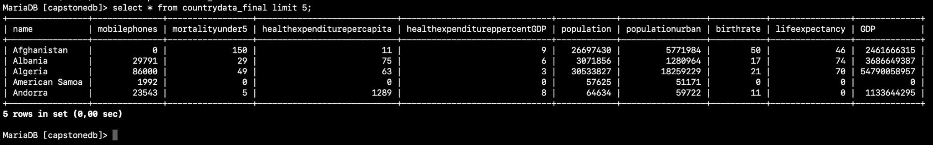



## And check the website

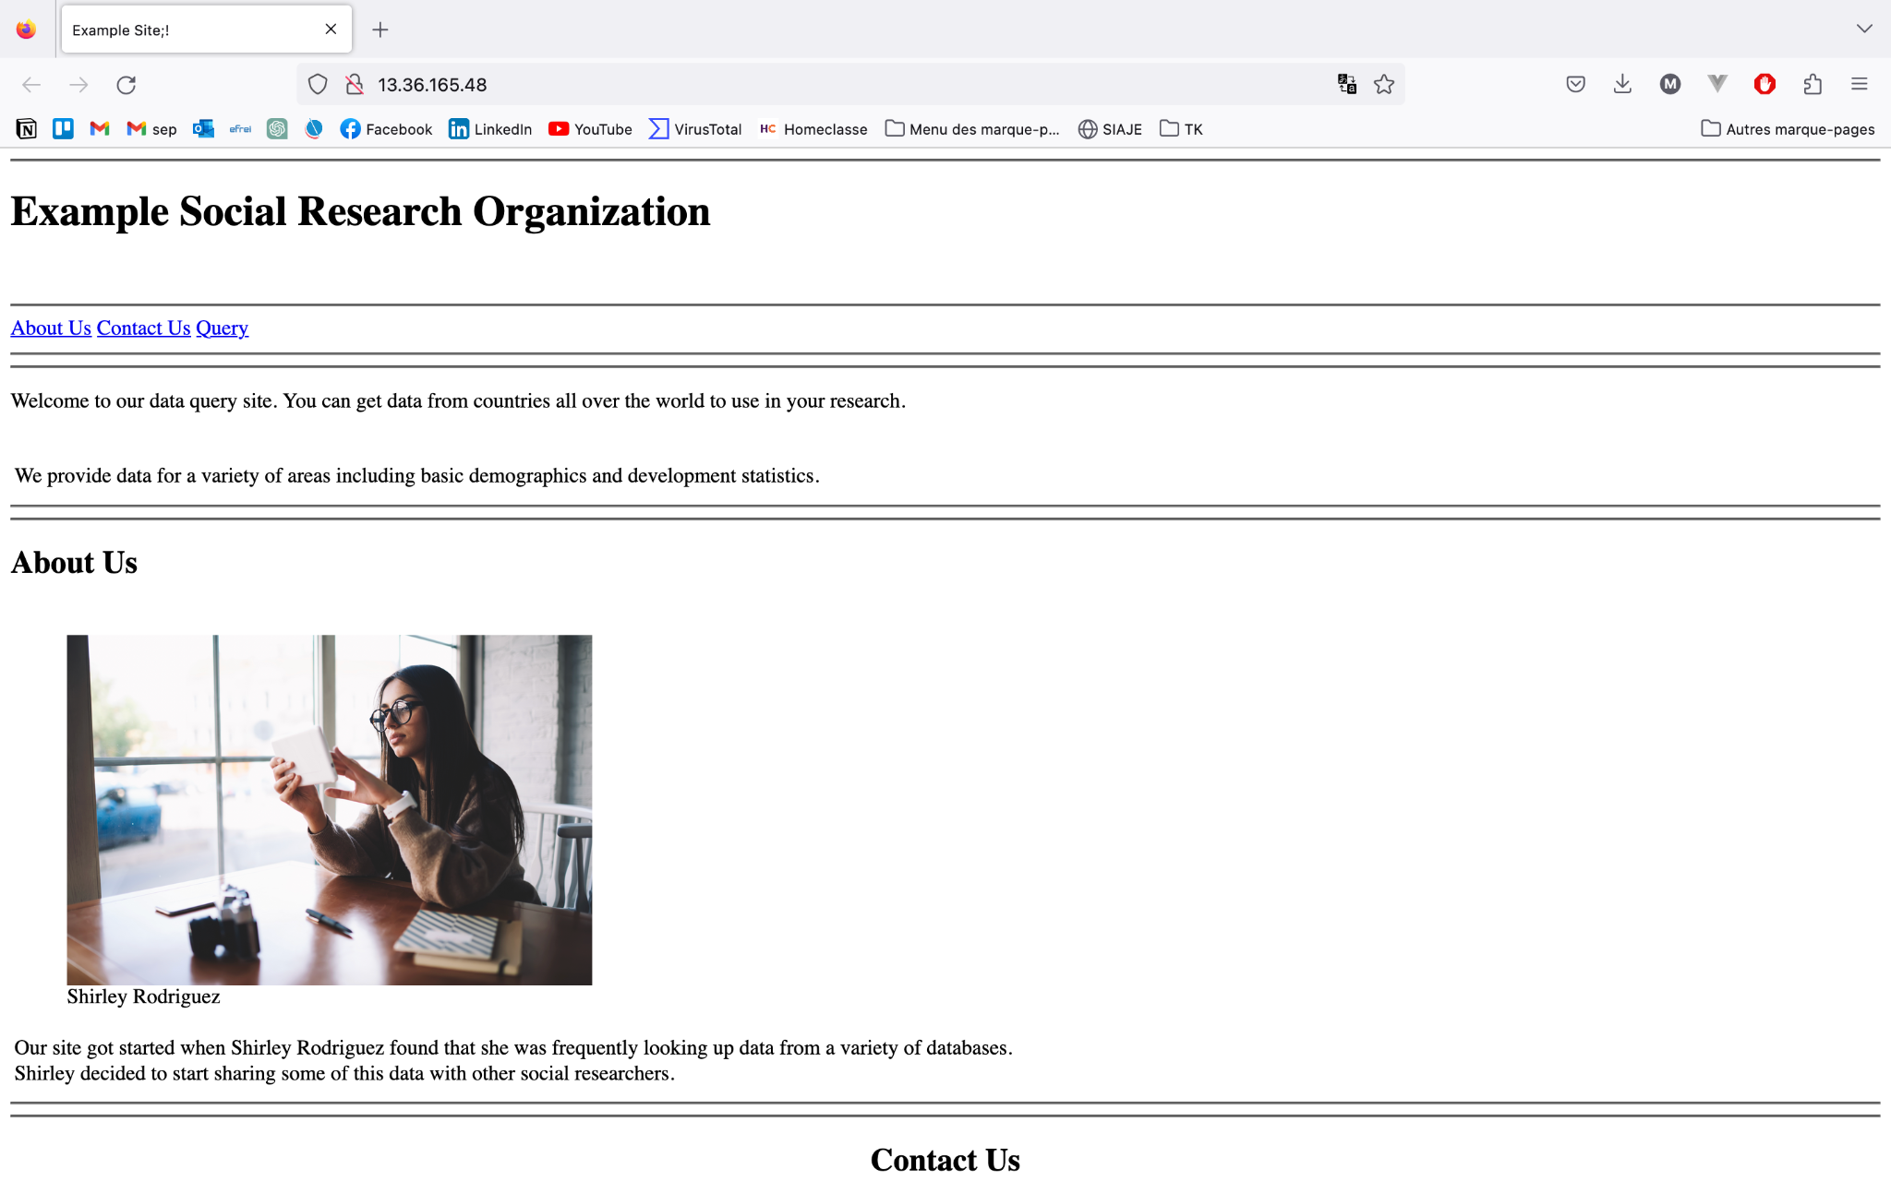

# Quiz

## IAM QUIZZ

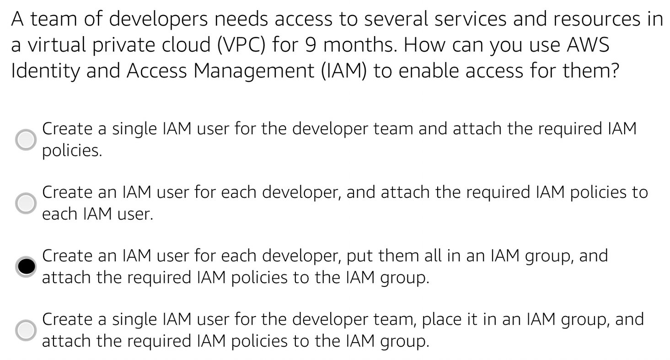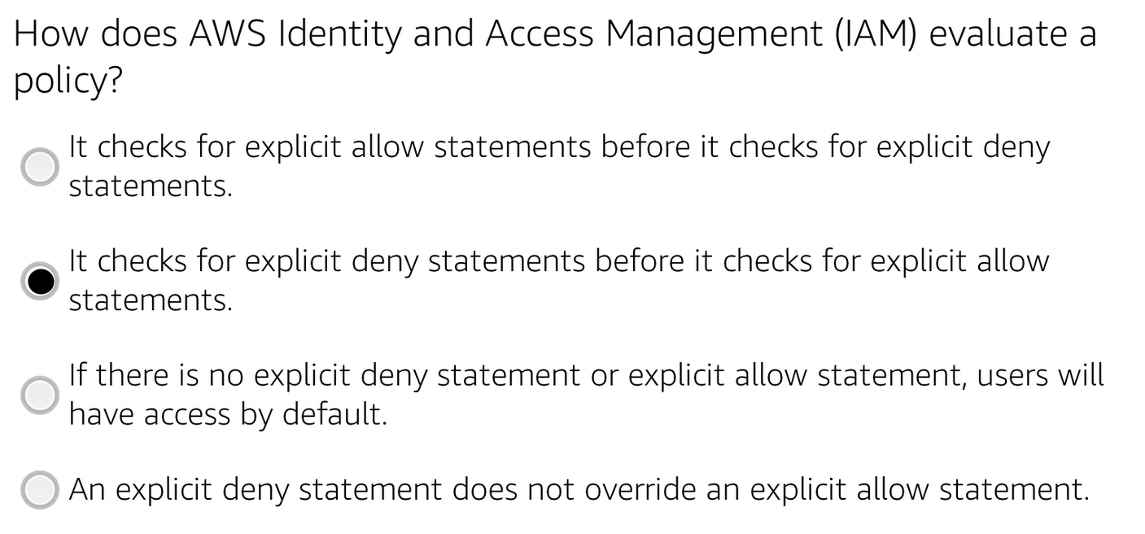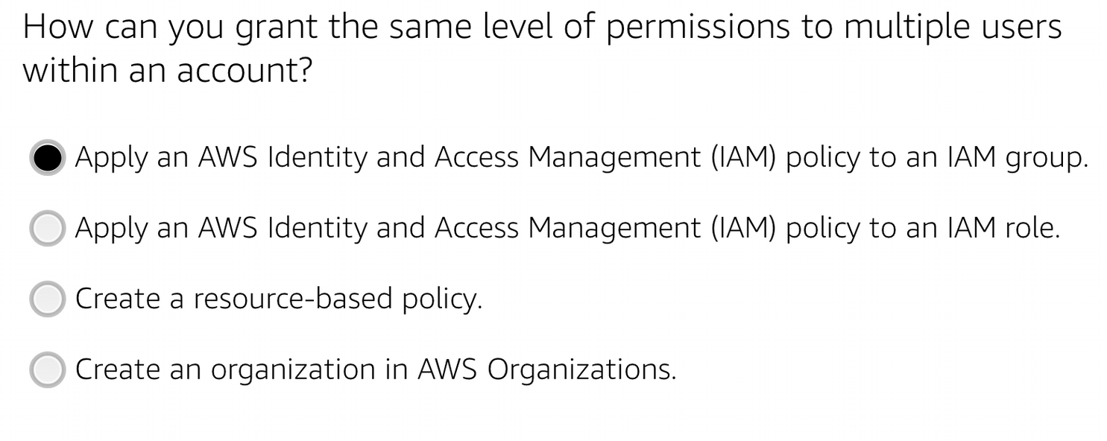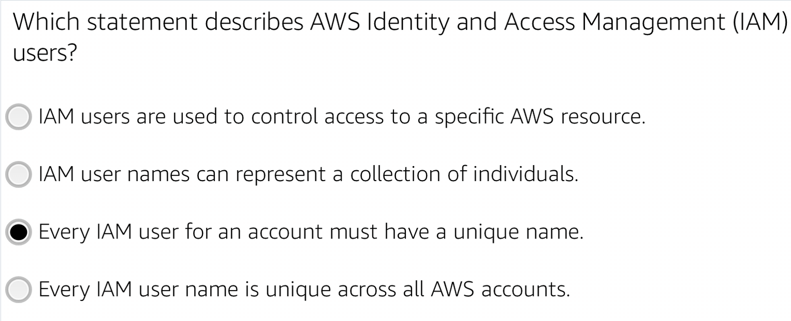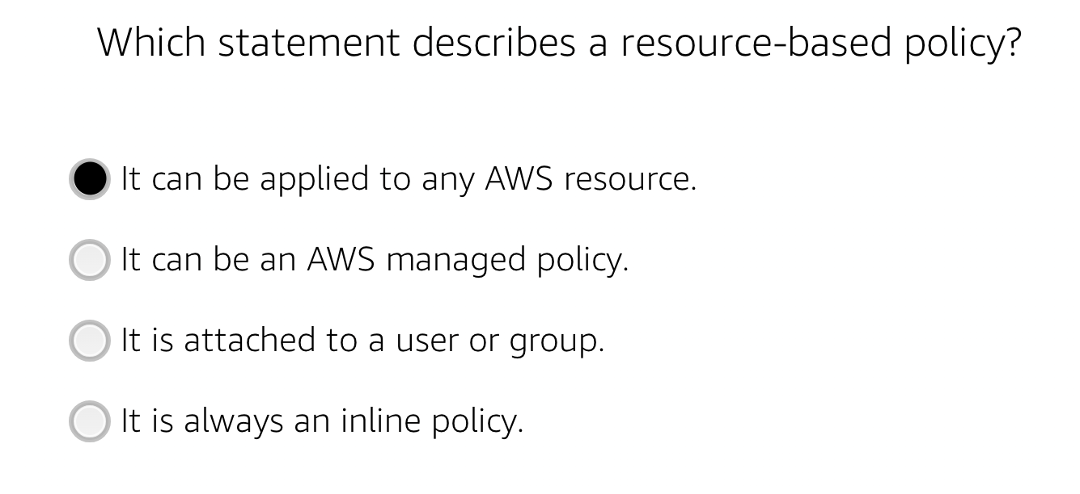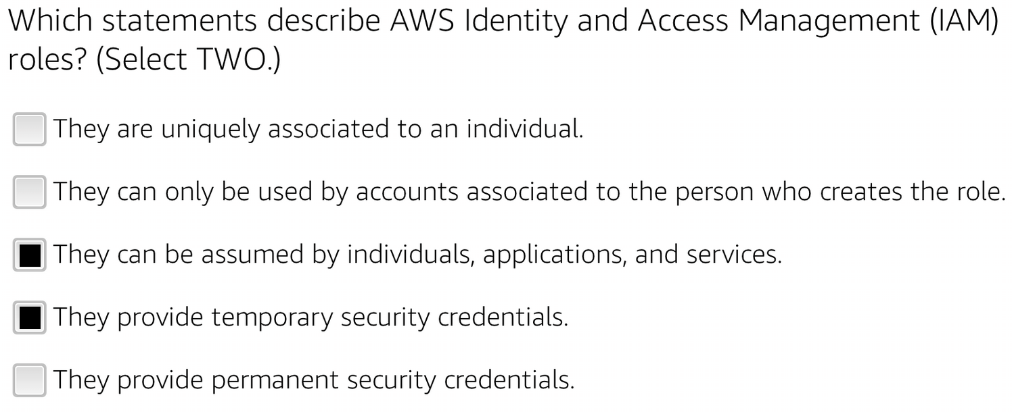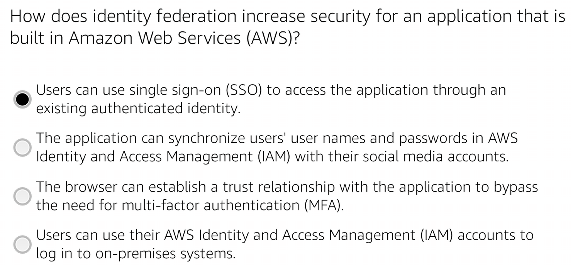

## Network quizz

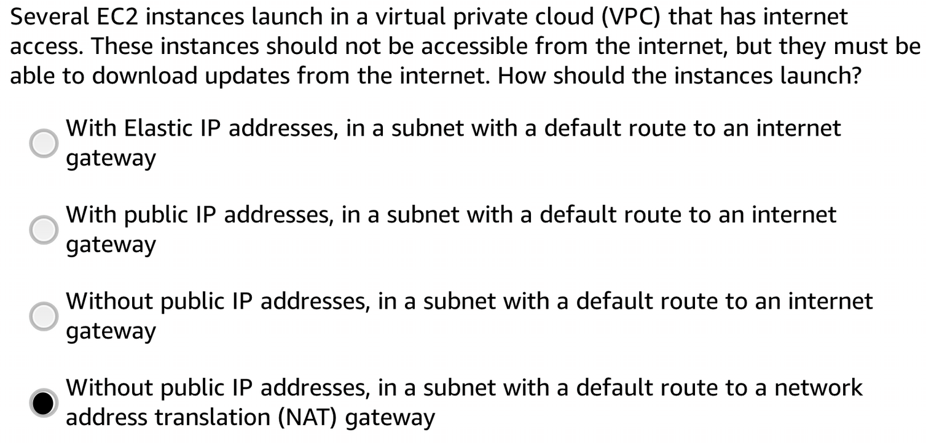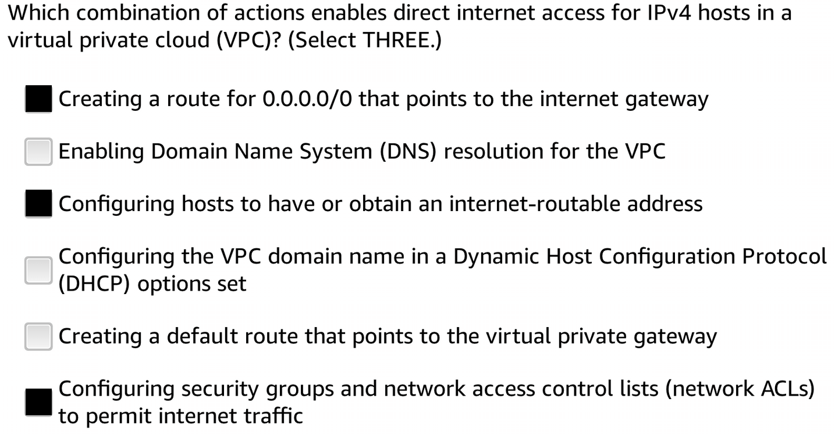

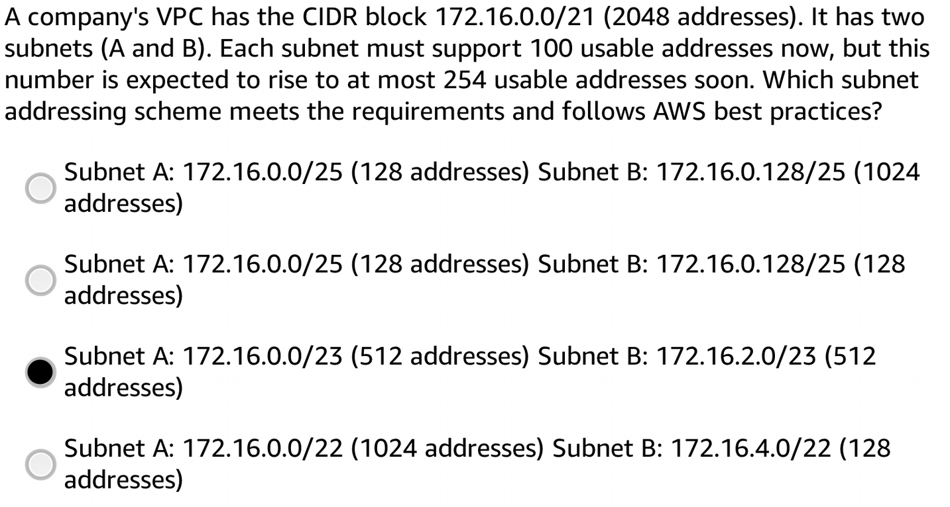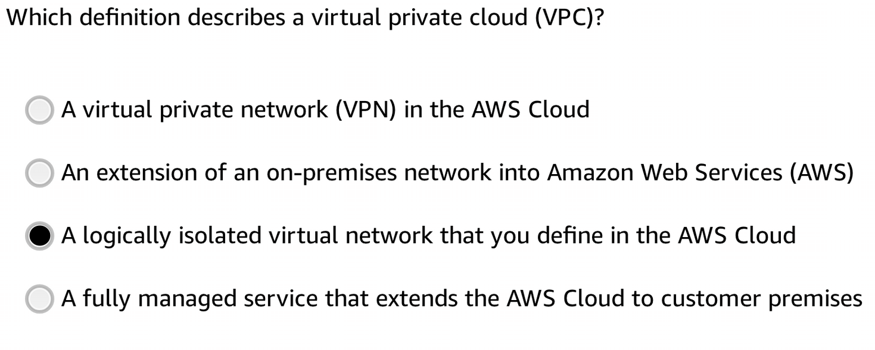

# IAM

Please evaluate below IAM policies

| {  "Version": "2012-10-17",  "Statement": [  {  "Sid": "AllowEC2AndS3",  "Effect": "Allow",  "Action": [  "ec2:RunInstances",  "ec2:TerminateInstances",  "s3:GetObject",  "s3:PutObject"  ],  "Resource": [  "arn:aws:ec2:us-east-1:123456789012:instance/*",  "arn:aws:s3:::example-bucket/*"  ]  }  ] } |
| --- |

### **Question: What actions are allowed for EC2 instances and S3 objects based on this policy? What specific resources are included?**

**Allowed Actions for EC2 Instances:**

* ec2:RunInstances: allows the user to launch new EC2 instances.
* ec2:TerminateInstances: allows the user to terminate EC2 instances.

**Allowed Actions for S3 Objects:**

* s3:GetObject: allows the user to retrieve (read) objects from an S3 bucket.
* s3:PutObject: allows the user to upload (write) objects to an S3 bucket.

**Specific Resources Included:**

* EC2 Instances: allows actions on all EC2 instances in the us-east-1 region for the AWS account with the ID 123456789012. The resource ARN for this includes all instances under the given account and region: "arn:aws:ec2:us-east-1:123456789012:instance/*".
* S3 Objects: allows actions on all objects (files) within the S3 bucket named example-bucket. The resource ARN for this includes all objects within the specified bucket: "arn:aws:s3:::example-bucket/*".

| {  "Version": "2012-10-17",  "Statement": [  {  "Sid": "AllowVPCAccess",  "Effect": "Allow",  "Action": [  "ec2:DescribeVpcs",  "ec2:DescribeSubnets",  "ec2:DescribeSecurityGroups"  ],  "Resource": "*",  "Condition": {  "StringEquals": {  "aws:RequestedRegion": "us-west-2"  }  }  }  ] } |
| --- |

### **Question: Under what condition does this policy allow access to VPC-related information? Which AWS region is specified?**

**Condition:**

* "StringEquals": used to check if a specific condition key has a particular value.
* "aws:RequestedRegion": "us-west-2": This specifies the condition key aws:RequestedRegion and sets the required value to "us-west-2".

**Effect:**

* Effect: "Allow": allows the specified actions (ec2:DescribeVpcs, ec2:DescribeSubnets, and ec2:DescribeSecurityGroups) if the specified conditions are met.

**Allowed Actions for EC2:**

* ec2:DescribeVpcs: allows the user to describe (retrieve information about) VPCs (Virtual Private Clouds) in the us-west-2 region.
* ec2:DescribeSubnets: allows the user to describe (retrieve information about) subnets within the us-west-2 region.
* ec2:DescribeSecurityGroups: allows the user to describe (retrieve information about) security groups within the us-west-2 region.

**Resource:**

* Resource: "*": allows the specified actions on all resources in the AWS account.

| {  "Version": "2012-10-17",  "Statement": [  {  "Sid": "AllowS3ReadWrite",  "Effect": "Allow",  "Action": ["s3:GetObject", "s3:PutObject", "s3:ListBucket"],  "Resource": [  "arn:aws:s3:::example-bucket",  "arn:aws:s3:::example-bucket/*"  ],  "Condition": {  "StringLike": {  "s3:prefix": ["documents/*", "images/*"]  }  }  }  ] } |
| --- |

### **Question: What actions are allowed on the "example-bucket" and its objects based on this policy? What specific prefixes are specified in the condition?**

**Allowed Actions on the Bucket:**

* s3:ListBucket: allows the user to list the contents of the "example-bucket". It does not grant permission to access the individual objects within the bucket, only the ability to see the list of objects.

**Allowed Actions on Objects within the Bucket:**

* s3:GetObject: allows the user to retrieve (read) objects from the "example-bucket".
* s3:PutObject: allows the user to upload (write) objects to the "example-bucket".

**Resource ARNs:**

* "arn:aws:s3:::example-bucket": This specifies the ARN (Amazon Resource Name) of the "example-bucket" itself, allowing the specified actions on the bucket itself.
* "arn:aws:s3:::example-bucket/*": This specifies the ARN of all objects within the "example-bucket", allowing the specified actions on any object within the bucket.

**Condition:** The policy includes a condition that restricts the allowed actions to objects with specific prefixes. The condition is as follows:

* "s3:prefix": ["documents/*", "images/*"]: This condition uses the StringLike comparison to match object keys (or "prefixes") that start with either "documents/" or "images/". The * after each prefix indicates that there can be additional characters after "documents/" or "images/" in the object keys.

| {  "Version": "2012-10-17",  "Statement": [  {  "Sid": "AllowIAMUserCreation",  "Effect": "Allow",  "Action": "iam:CreateUser",  "Resource": "arn:aws:iam::123456789012:user/${aws:username}"  },  {  "Sid": "AllowIAMUserDeletion",  "Effect": "Allow",  "Action": "iam:DeleteUser",  "Resource": "arn:aws:iam::123456789012:user/${aws:username}"  }  ] } |
| --- |

### 

### **Question: What actions are allowed for IAM users based on this policy? How are the resource ARNs constructed?**

**Allowed Action:**

* iam:CreateUser: allows the IAM user to create a new IAM user.

**Allowed Action:**

* iam:DeleteUser: allows the IAM user to delete their own IAM user account.

**Resource ARNs:**

* "arn:aws:iam::123456789012:user/${aws:username}": This is the format of the resource ARN (Amazon Resource Name) for both the "CreateUser" and "DeleteUser" actions.
* ${aws:username}: This is a special variable used in the resource ARN. When an IAM user performs an action covered by this policy, the ${aws:username} variable will be replaced with the username of the IAM user performing the action. This means that the IAM user is only allowed to create or delete their own IAM user account, as the ARN will be specific to their own username.

| {  "Version": "2012-10-17",  "Statement": {  "Effect": "Allow",  "Action": ["iam:Get*", "iam:List*"],  "Resource": "*"  } } |
| --- |

### **Questions:**

This IAM policy grants access to Access Management (IAM) service and AWS Identity.

**Does it allow you to create an IAM user, group, policy, or role?** No, this policy only allows read-only actions (iam:Get* and iam:List*) on IAM-related resources. It does not include any write actions, so creating IAM entities like users, groups, policies, or roles is not permitted.

**Name at least three specific actions that the iam:Get* action allows.** The iam:Get* action allows to perform various read operations on IAM resources. Some specific actions included are:

* iam:GetUser: allows to retrieve information about an IAM user, such as username, ARN, groups, and attached policies.
* iam:GetGroup: allows to retrieve information about an IAM group, including group name, ARN, group members, and attached policies.
* iam:GetPolicy: allows to retrieve information about an IAM policy, including its policy document, ARN, and policy details.

| {  "Version": "2012-10-17",  "Statement": [  {  "Condition": {  "StringEquals": {  "ec2:InstanceType": ["t2.micro", "t2.small"]  }  },  "Resource": "arn:aws:ec2:*:*:instance/*",  "Action": ["ec2:RunInstances", "ec2:StartInstances"],  "Effect": "Deny"  }  ] } |
| --- |

### **Questions:**

* **What actions does the policy allow?** The provided policy allows two actions related to Amazon EC2 instances:
  + ec2:RunInstances: allows the user to launch new EC2 instances.
  + ec2:StartInstances: allows the user to start existing EC2 instances.
* Say that the policy included an additional statement object, like this **example:**

| {  "Effect": "Allow",  "Action": "ec2:*" } |
| --- |

The additional statement grants full access (ec2:*) to all EC2-related actions. This means that all EC2 actions, including those related to instance management, security groups, volumes, etc., will be allowed.

**Policy with Both Statements:** If the policy included both the original statement (Deny ec2:RunInstances and ec2:StartInstances for t2.micro and t2.small) and the additional statement (Allow all ec2 actions), the policy would behave as follows:

* The original statement with "Effect": "Deny" would take precedence. It would deny the ec2:RunInstances and ec2:StartInstances actions for instances with t2.micro or t2.small instance types.
* The additional statement with "Effect": "Allow" would grant unrestricted access to all other EC2 actions, including the ability to terminate instances.

# Big Data - Data Visualization With AWS QuickSight

**Sum of revenue by admit date**

Aggregate by month dates for clarity

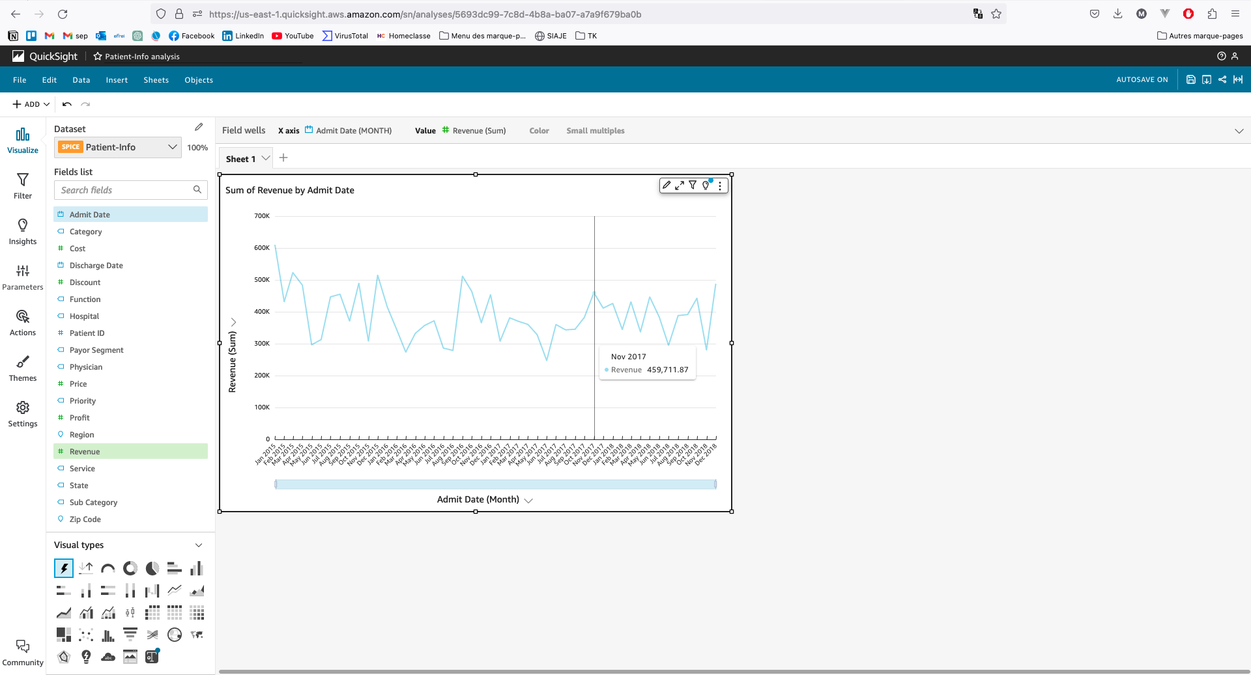

**Sum of profits by hospital**

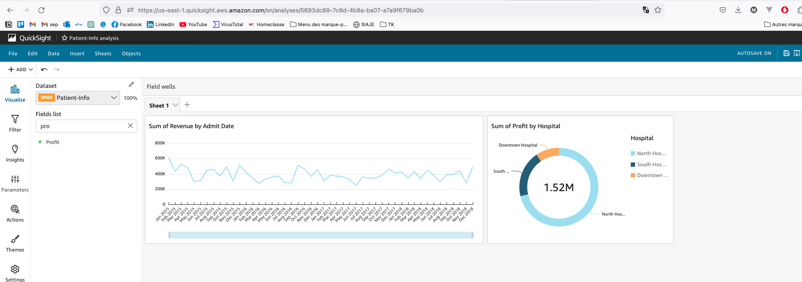

**Calculated field Year, YoY Profit 2017 vs 2018 and YoY Revenue 2017 vs 2018 for next chart**

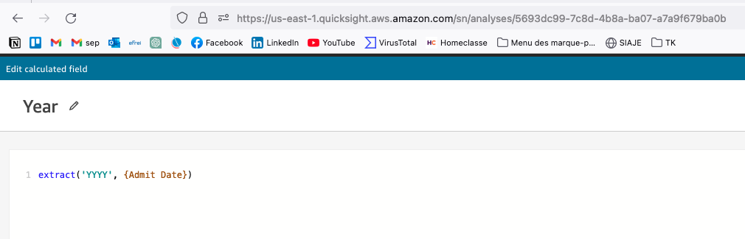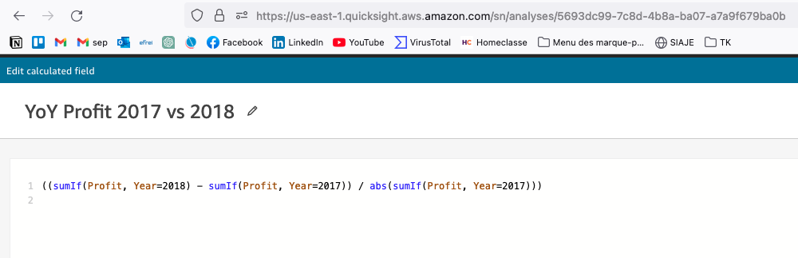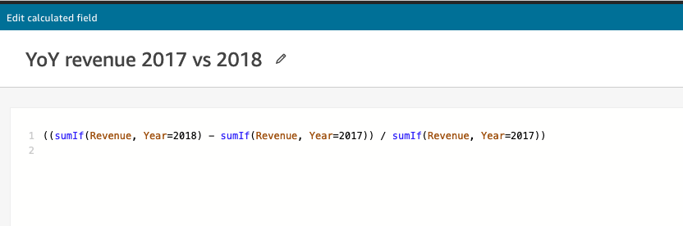

**Use the previous calculated field for KPI and display the result in percent**

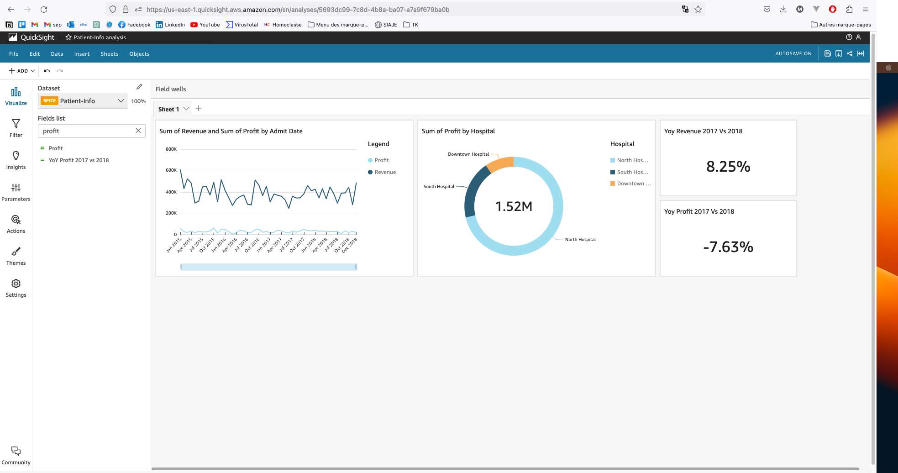

**Use bar charts for Sum of cost by category and admit date**

**Add a filter date and category target some of them**

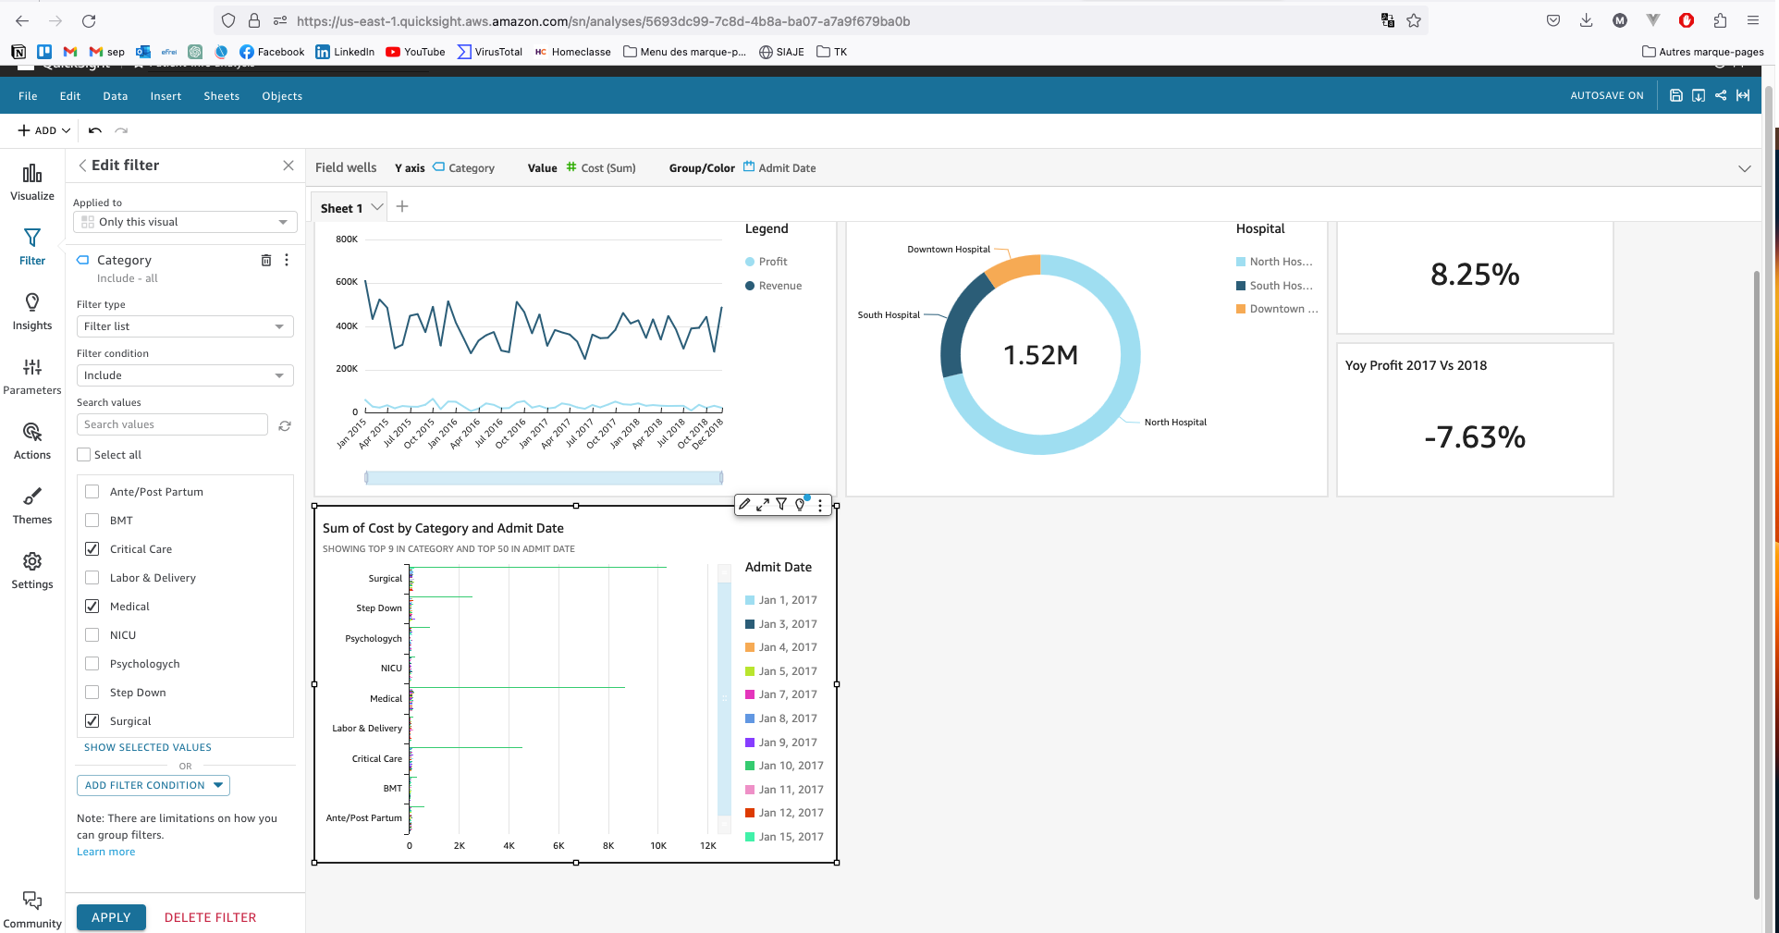

**Use pivot table to show the sum of profit by category and admit date**

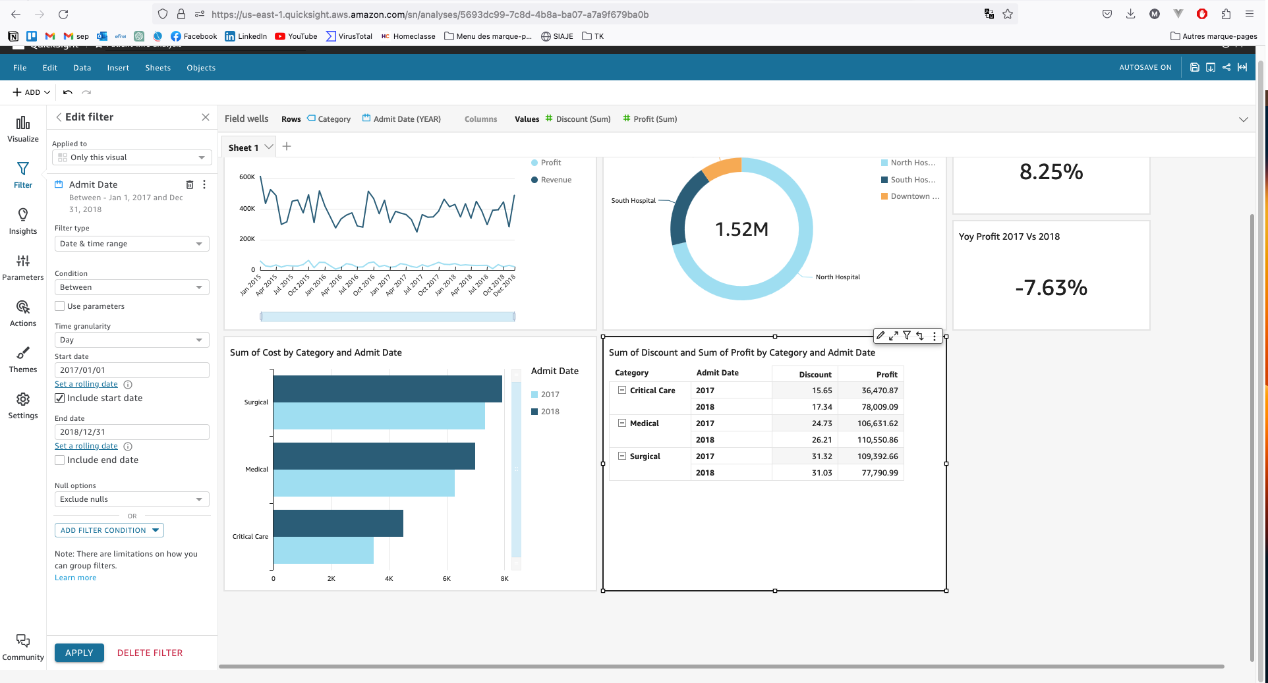

**And finally we add the count of physicians by function**

